SC2/WG2N XXXX **DATE:** 2016‐09 Update: WG2N4696 **ISO/IEC JTC 1/SC 2/WG 2**   
**Universal Multiple-Octet Coded Character Set (UCS) - ISO/IEC 10646**   
 **Secretariat: ANSI**

|  |  |
| --- | --- |
| **Doc Type** | **Working Group Document** |
| **Title** | **Updated Proposal for encoding Shuishu in the SMP of the UCS** |
| **Source** | **China** |
| **Reference** | **N4638 and N4696** |
| **Action** | **For consideration by WG2** |
| **Date** | **2016-09** |

1

2

**Introduction**

This proposal is updating the previous proposal SC2/WG2 N4696 “Preliminary Proposal for encoding Shuishu (also called Sui script) in the SMP of the UCS”. The methodology and character counts have benefitted greatly from the help of Professor Zhao Liming of Qinghua University.

This proposal has received the wide approval of the Shui people throughout China, on August 31, 2015, the approval meeting for the Proposal for encoding Shuishu in the SMP of the UCS was held in Duyun Guizhou China by Guizhou Shui Language and Culture Society. There were 31 participants including Shuishu masters, government leaders and language and script experts from Duyun, Sandu Shui Autonomous County, Dushan, Guiyang and Rongjiang. Other meetings were held on April 15, and June 27, 2016. Participants gave excellent suggestions, affirmed the work and supported this final proposal. There was a final meeting on July 26, 2016 to finalize the present Shuishu character mapping tables. See pictures in Appendix 5 (4)，which also includes a list of all those who helped to compile the whole Shuishu character mapping system.

Chen Zhuang, Zhao Liming, Daisy (Chingju) Lai, Wu Guibiao, Pan Chaolin, and Deborah Anderson have also given good input to this proposal. Donna Snyder of SIL International also helped with editing the English translation.

There are three main sections in this paper: 1.Transliteration scheme for character names, 2. Character count and Methodology, 3. SC2/WG2 N4696 Shuishu character table changes and updates, plus the Mapping tables of Shuishu Characters, Appendices and References.

**1**． **Transliteration scheme for naming Shuishu characters**

This proposal the Character namng is using Shui Romanized phonemic representations, all correspond with IPA pronounciations. According to former research and most updated phonological analysis by Daisy (Chingju) Lai, a Shui language researcher with SIL International, the Shui language contains forty-four consonants, eight vowels, eight diphthongs and eight tones. IPA is used in many publications, but there is a Romanized transcription now being used for writing the Shui language. In N4696 it was introduced in section II Shui phonology（as seen in table (1) below）. Romanized mapping is shown in bold capital letters, corresponding to the Chinese pinyin system （汉语拼音），which also meets government requirements. This transliteration scheme is   
acknowledged by the Sandu Shui minority autonomous county minority institute and university. Lai describes the development of this writing system (《水语拼音方案》（草案）) in her doctoral dissertation (Lai 2015). This Romanized transliteration scheme is also used for children as bilingual literacy text book (《水族文化进校 园》 Bring Shui Culture into Campus; see section 5. Appendix (3)). Also, students at Guizhou Minority University majoring in Shui language study also learn this scheme to transcribe their language.

3

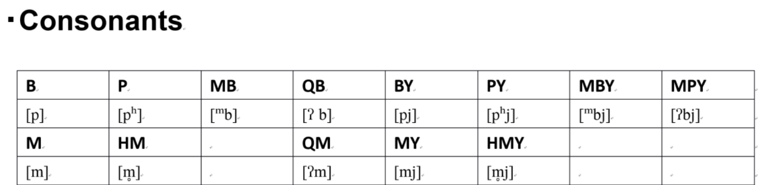

Table (1)

In this Romanized spelling system, the syllable final has a tonal marker. 1st tone is marked with-L, 2nd-Z, 3rd-C, 4th-X, 5th-S, 6th-H, 7th-S, and 8th- Ø (none). In this mapping system numbers replace final tonal letters for ease of indexing. Also it is easier to recognize syllable breaks. See examples below.

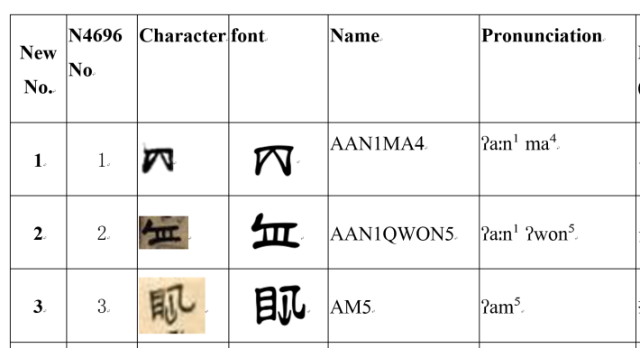

If there are homophones then the character name will use –A for the first character and –B for the second character. (See below)

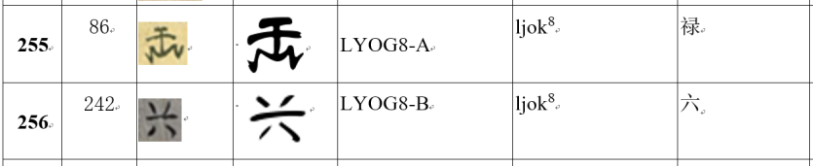

Deborah Anderson (personal communication) mentions naming Shuishu characters by code points. This is also a valid method, but at the present time, we will keep using the current index because the Shui researchers are more familiar with this method of locating the characters.

The Shui romanized phonemic representations with their corresponding Shui phoneme (IPA) pronounciations are listed in chart below. Romanized mapping is shown in bold capital letters.

**Initials**

|  |  |  |  |  |  |  |  |  |
| --- | --- | --- | --- | --- | --- | --- | --- | --- |
|  |  |  |  | **Pre-glottal** | **Palatalized and bilabialized Initial** | | | |
| **Bilabial** | **B** | **P** | **MB** | **QB** | **BY** | **PY** | **MBY** | **MPY** |
|  | [p] | [pʰ] | [ᵐb] | [ʔ b] | [pj] | [pʰj] | [ᵐbj] | [ʔbj] |
|  | **M** | **HM** |  | **QM** | **MY** | **HMY** |  |  |
|  | [m] | [m̥] |  | [ʔm] | [mj] | [m̥j] |  |  |

4

|  |  |  |  |  |  |  |  |  |
| --- | --- | --- | --- | --- | --- | --- | --- | --- |
| **Labial dental** | **F** | **V** | **W** | **QW** | **FY** | **VY** |  |  |
|  | [f] | [v] | [w] | [ʔw] | [fj] | [vj] |  |  |
| **Alveolar** | **D** | **T** | **ND** | **QD** | **DY** | **TY** | **NDY** | **NTY** |
|  | [t] | [tʰ] | [nd] | [ʔd] | [tj] | [tʰj] | [ndj] | [ʔdj] |
|  | **N** | **HN** |  | **QN** | **DW** |  | **NDW** | **QDW** |
|  | [n] | [n̥] |  | [ʔn] | [tw] |  | [ndw] | [ʔdw] |
|  | **NN** | **HNN** |  | **QNN** | **NY** | **HNY** | **QNY** |  |
|  | [ɳ] | [ɳ̊] |  | [ʔɳ] | [nj] | [n̥j] | [ʔnj] |  |
| **Lateral** | **L** |  | **Y** | **QW** | **LY** | **LW** |  |  |
|  | [l] |  | [j] | [ʔw] | [lj] | [lw] |  |  |
| **Velar** | **G** | **K** | **XG** | **QXG** | **GW** | **KW** |  |  |
|  | [k] | [kʰ] | [ɣ] | [ʔɣ] | [kw] | [kʰw] |  |  |
|  | **NG** | **HNG** |  | **QNG** | **NGW** | **QNGW** |  |  |
|  | [ŋ] | [ŋ̊] |  | [ʔŋ] | [ŋw] | [ʔŋw] |  |  |
|  | **GG** | **KK** | **XGG** | **H** |  |  |  |  |
|  | [q] | [qʰ] | [ʁ] | [h] |  |  |  |  |
| **Fricative** | **Z** | **C** | **S** | **R** | **ZY** | **CY** | **SY** | **RY** |
|  | [ts] | [tsʰ] | [s] | [z] | [tsj] | [tsʰj] | [sj] | [zj] |
|  | **J** | **Q** | **X** | **XX** | **ZW** | **CW** | **SW** |  |
|  | [ȶ] | [ȶʰ] | [ɕ] | [x] | [tsw] | [tsʰw] | [sw] |  |

**Rhymes**

|  |  |  |  |  |  |  |  |
| --- | --- | --- | --- | --- | --- | --- | --- |
| **Sigle vowel** | **A** | **AA** | **O** | **E** | **EE** | **I** | **U** |
|  | [a] | [aː] | [o] | [ə] | [e] | [i][ ɿ] | [u] |
| **Dipthong** | **AI** | **EI** | **AO** | **OU** |  |  |  |
|  | [aːi] | [ai] | [aːu] | [au] |  |  |  |
|  | **EEU** | **OI** | **UI** | **IU** |  |  |  |
|  | [eu] | [oi] | [ui] | [iu] |  |  |  |
| **With coda** | **IM** | **EEM** | **AAM** | **AM** | **OM** | **UM** |  |
|  | [im] | [em] | [aːm] | [am] | [om] | [um] |  |
|  | **IN** | **EEN** | **AAN** | **AN** | **ON** | **UN** | **EN** |
|  | [in] | [en] | [aːn] | [an] | [on] | [un] | [en] |
|  | **ING** | **EENG** | **AANG** | **ANG** | **ONG** | **UNG** | **ENG** |
|  | [iŋ] | [eŋ] | [aːŋ] | [aŋ] | [oŋ] | [uŋ] | [əŋ] |
|  | **IB** | **EEB** | **AAB** | **AB** | **OBː** | **UB** |  |
|  | [ip] | [ep] | [aːp] | [ap] | [op] | [up] |  |
|  | **ID** | **EED** | **AAD** | **AD** | **OD** | **UD** | **ED** |
|  | [it] | [et] | [aːt] | [at] | [ot] | [ut] | [ət] |
|  | **IG** | **EEG** | **AAG** | **AG** | **OG** | **UG** | **EG** |
|  | [ik] | [ek] | [aːk] | [ak] | [ok] | [uk] | [ək] |

5

**Tones**

Here is the Romanized tonal mapping table. Tonal numbers at syllable finals are used for the character names, because it is better for indexing and easier for Shui speakers to find the characters.

|  |  |  |  |  |  |  |  |  |
| --- | --- | --- | --- | --- | --- | --- | --- | --- |
| **Tone number** | **1** | **2** | **3** | **4** | **5** | **6** | **7** | **8** |
| Tone Symbol |
| L | Z | C | X | S | H | S | Ø |
| Pitch Value | 13 | 31 | 33 | 52 | 35 | 55 | 55 | 32 |
| (short) 35 | (short) 42 |
| (long) | (long) |

**2**．**Character count and Methodology (Updated from N4696 section 5)**

（**1**）**Source texts**

The source texts are 17 important Shuishu texts from 8 volumes.

Source texts list (Shuishu texts materials) for this proposal (8 volumes and 17 books). Each source text includes an interlinearized translation are published or in the process of publication.

|  |  |  |
| --- | --- | --- |
| Source Book No. | shortened form for the source texts | Source Book name (Chinese) |
| S1 | **Tsinghua Shuishu Text-10 Books** | S1 《<清华大学馆藏水书文 献 10 本>解读》 |
| S2 | **Book of Golden Day** | S2 《泐金-纪日卷》 |
| S3 | **Gold and Silver** | S3 《金银卷》 |
| S4 | **Lu-Dao** | S4 《<陆道根原>解读》 |
| S5 | **Cycle of Sixty Years** | S5 《<六十甲子时辰>解读》 |
| S6 | **Tanju (Nine Stars)** | S6 《贪巨九星歌本》 |
| S7 | **Sixty Dragon** | S7 《六十龙备要》 |
| S8 | **Jixing (Lucky Star)** | S8 《吉星》 |

Please see appendix 5（1）List of Shuishu characters source texts and book covers.

（**2**）**Methodology**

In the process of compiling the **Shuishu Character Table**, we first analyzed the total number of characters and the character count for each character of each book and then integrated the statistics into the table manually.

6

All the characters in the Shuishu mapping table were evaluated and chosen by Shuishu masters. Symbols were scanned as screen shots from the original texts. Each character was analyzed according to frequency, pronunciation, and meaning. Variations were also taken into consideration. Representative characters from the variations were chosen by highest frequency, most commonly used, and the best looking shape according to the Shuishu masters. Some Shuishu characters have more than one meaning, and some have more than one pronunciation. Final decisions of which character to choose were made by consensus of the Shui community through the Shuishu masters and their researchers.

The person responsible for each book made the frequency count table for that book. Then Zhao Liming, Yao Qinjun and Weishi Fang, Pan Zhongxi, Yao Binglie, Wei Jinshi, and others integrated, summarized and checked the results, including the total number of characters and the word count of each character and variants, which allows a quick search by the meaning of a character.

The statistics are practical and realistic. Each frequency count table objectively reveals the features and rules of Shuishu. The results provide scientific basis for the digitalization and coding of Shuishu for the future.

Examples below are part of the frequency count table from source book ‘Gold and Silver’.

|  |  |  |  |  |  |  |  |
| --- | --- | --- | --- | --- | --- | --- | --- |
| No | Character | frequency | pronounciation | Chinese Meaning | varients | frequency | Total number |
| 1 |  | 381 | ɕi³ | 子 |  |  | 612 |
|  |  |  |  |  |  | 231 |  |
| 2 |  | 612 | su³ | 丑 |  |  | 612 |
| 3 |  | 142 | ji² | 寅 |  |  | 530 |
|  |  |  |  |  |  | 85 |  |
|  |  |  |  |  |  | 48 |  |
|  |  |  |  |  |  | 8 |  |
|  |  |  |  |  |  | 6 |  |
|  |  |  |  |  |  | 13 |  |
|  |  |  |  |  |  | 12 |  |
|  |  |  |  |  |  | 92 |  |
|  |  |  |  |  |  | 11 |  |

7

|  |  |  |  |  |  |  |  |
| --- | --- | --- | --- | --- | --- | --- | --- |
|  |  |  |  |  |  | 113 |  |
| 4 |  | 228 | maːu⁴ | 卯 |  |  | 585 |
|  |  |  |  |  |  | 222 |  |
|  |  |  |  |  |  | 123 |  |
|  |  |  |  |  |  | 12 |  |
| 5 |  | 303 | sən² | 辰 |  |  | 627 |
|  |  |  |  |  |  | 223 |  |
|  |  |  |  |  |  | 62 |  |

|  |  |
| --- | --- |
| **3**． | **SC2/WG2 N4696 Shuishu character table changes and updates** |

The source texts are 17 important Shuishu texts from 8 volumes, please see appendix table（4）List of Shuishu characters source texts.

According to many years of Shui script research, the new table with 486 characters can satisfy the basic Shuishu research needs at the present time. Only some words failed to be read and translated. In the future about 200 UCS code points may be needed, when the Shui script is researched further.

The new table contains all the changes and the font set. The new font set consists of 486 characters (40 characters were eliminated as variants or corrections and 41 new characters were added.) See 4. The mapping table of Shuishu Characters. Detailed reasons for all the changes are found in the last column “Notes” of the table.

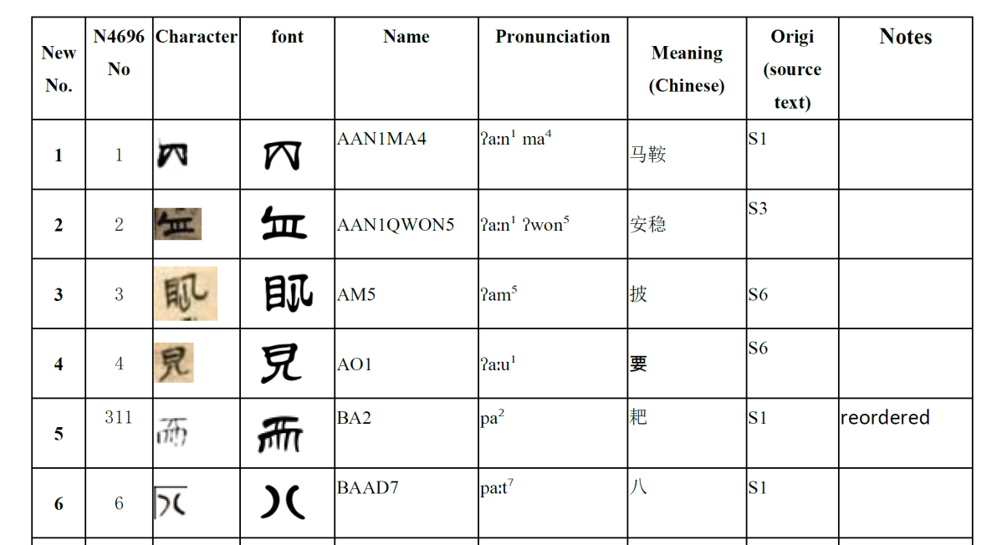

8

（**1**） **Reasons for deletions**   
1. **repetition**   
Some characters in the WG2N4696 Shuishu fundamental character table have the same form but the

pronunciation is not the same so we combine two entries as the same character. There is only one frequently

used character in this category. E.g. No. 242 “六 (six) ”

. It lists as No. 256 in the new table.

2. **same usage**

is the same as No. 243 “禄存星(Paul put stars) ”

Some characters have the same meanings and usage but different forms, this paper only keeps the

|  |  |  |  |  |
| --- | --- | --- | --- | --- |
| most frequently used one. E.g. old No. 312 “破坏”“destroy” |  | , and No. 313 |  | , No. 31 |

4 破军星( star of exodus from the Earth )

, these forms in Shuishu are interchangeable. The n

|  |  |  |
| --- | --- | --- |
| ew character table keeps the most frequently used form |  | for 破军星. It is listed as No. 321 in |

the new table.

3. **variants**

From the source texts, we calculated the frequency of the characters. Each text has lots of variants. For

|  |  |  |  |  |  |  |  |  |  |  |  |  |
| --- | --- | --- | --- | --- | --- | --- | --- | --- | --- | --- | --- | --- |
| example in the source text《吉星》“lucky star”，the character 甲（1st heavenly stem） has“ | | | | | | | | | | | ”“ | ” |
| “ | ”“ | ”“ | ”“”“”“ | | ”“”“ | |  | ”“ |  | ” 11 kinds of writings. | | |
| We chose the most representative character | | | |  | | as our standard form. Here is from the Character count table. | | | | | | |

|  |  |  |  |  |  |  |  |  |  |  |  |
| --- | --- | --- | --- | --- | --- | --- | --- | --- | --- | --- | --- |
| No | Chinese | Chosen one | | Pronunciati on | Variants and frequency | | | | | | total |
| 1 | 甲 |  | 20 | ȶaːp⁷ |  | 58 |  | 33 |  | 1 |  |
|  |  |  |  |  |  | 4 |  | 1 |  | 2 |  |
|  |  |  |  |  |  | 12 |  | 2 |  | 34 |  |
|  |  |  |  |  |  | 1 |  |  |  |  | 168 |

9

4. **extra character in the old table**   
 This paper has corrected the character table WG2N4696 which has doubly represented characters. E.g. No.

|  |  |  |  |  |  |  |  |
| --- | --- | --- | --- | --- | --- | --- | --- |
| 79 |  | ”, No. 136 | ”, No.164 |  | , No. 337 |  | , We have chosen only one |

character from each pair.

5. **corrections in the old table**

|  |  |  |  |  |  |  |  |  |
| --- | --- | --- | --- | --- | --- | --- | --- | --- |
| The old No. 200 |  | is repeated again as No. 254 |  | | . In the new table | |  | is No. 268, |
| now is No 443. AlsoNo. 312 includesdifferent characters | | | |  | | , they are different characters, so | | |

 is now No. 321 in the new chart and

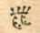 is newly added No 322.

6. **choosing the most representative or standard character**   
In the original WG2N4696 proposal, some characters' writing is not standard, this paper has chosen the

|  |  |  |  |  |  |  |  |  |
| --- | --- | --- | --- | --- | --- | --- | --- | --- |
| representative character and most frequently used instead. E.g. old table No 193 九“nine” | | | | | | |  | ( from |
| source text:Lud-dao) , replaces thecharacter | |  | | ( from source text：Sixty Dragon）in the new table No. 211. | | | | |
| Old table No. 239 廉贞星 “LianZhen star” |  | | ( from source text: Gold Sliver) replaces | |  | ( from source | | |

text: Sixty Dragon) listedin the new table as No. 252.

（**2**） **Added Characters**

41 new character entries are added.

There are a small number of characters that could not be read. After some Shui Script masters from

different Shui areas got together and compared these characters and gave their advice, this paper added the new

|  |  |  |  |  |
| --- | --- | --- | --- | --- |
| characters e.g. from source text: Tsinghua Shuishu text -10 books, the character | | |  | 四散“scatter” is added |
| as No. 442. |  | 灭门 “Bad Blood” is listed as No. 282 in the new table.. |

10

（**3**）**Index reordered**

The old chart was indexed alphabetically by pronunciation. Due to the combined work of two counties, Sandu

and Libo, some character pronunciations are different. After further checks, this paper unified the

pronunciation to the Sandu Sandong Bannan village dialect pronunciation which is considered a standard for the

Shui speaking community; most Shui script publications are using this dialect. E.g. old No. 5 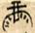 ʔaːu³（AO3）”changed to “ʁaːu³（XGGAO3）”，and after indexing became No. 435. Another example, old No. 398 

meaning 膨胀“expand”，changed to its pronunciation in Shui “sal bongz”, so after indexing it is listed as No.

365. Due to changing the pronunciation the numbers are then reordered in the index.

Most of the characters that have been reordered are because of the adjustment of pronunciation or

correction of meaning. These changes have all been agreed upon by various Shui experts and professors.

（**4**）**Categorizing**

Shuishu working teams try to categorise the 486 characters into 13 catogorie.

|  |  |  |  |  |  |  |
| --- | --- | --- | --- | --- | --- | --- |
| catogory | Chinese | English | |  |  |  | | --- | --- | --- | | How | many | Shuishu |   characters |
| 1 | 九星 | Nine Stars | 9 |
| 2 | 二十八宿 | Lunar mansions | 28 |
| 3 | 数字 | Numerals | 18 |
| 4 | 十天干 | Heavenly Stems | 10 |
| 5 | 十二地支 | Earthly Branches | 12 |
| 6 | 时间 | Time | 13 |
| 7 | 方位地点 | location | 14 |
| 8 | 五行八卦阴阳 | Wuxing/Ba gua/Yin and Yang | 22 |
| 9 | 动作行为 | Action | 119 |
| 10 | 水书条目名称 | Shuishu book names | 39 |
| 11 | 实物 | material object | 89 |
| 12 | 人及动物 | Human and animal | 32 |
| 13 | 其他 | other | 81 |
|  |  |  | Total 486 |

Detail character catogory sets are listed in section 4 (4) “Categorizd Shuishu Characters mapping table”.

11

**4**． **The mapping table of Shuishu Characters**

（**1**）**The mapping table of Shuishu Characters**

|  |  |  |  |  |  |  |  |  |
| --- | --- | --- | --- | --- | --- | --- | --- | --- |
| **New No.** | **N4696 No** | **Character** | **font** | **Name** | **Pronunciation** | **Meaning (Chinese)** | **Origi**  **(source text)** | **Notes** |
| **1** | 1 |  |  | AAN1MA4 | ʔaːn¹ ma⁴ | 马鞍 | S1 |  |
| **2** | 2 |  |  | AAN1QWON5 | ʔaːn¹ ʔwon⁵ | 安稳 | S3 |  |
| **3** | 3 |  |  | AM5 | ʔam⁵ | 披 | S6 |  |
| **4** | 4 |  |  | AO1 | ʔaːu¹ | 要 | S6 |  |
| **5** | 311 |  |  | BA2 | pa² | 耙 | S1 | reordered |
| **6** | 6 |  |  | BAAD7 | paːt⁷ | 八 | S1 |  |
| **7** | 7 |  |  | BAAG8 | paːk⁸ | 白 | S3 |  |
| **8** | 8 |  |  | BAAN2 | paːn² | 篱笆 | S6 |  |
| **9** | 9 |  |  | BAI1 | paːi¹ | 去 | S6 |  |
| **10** | 394 |  |  | BAI1QNUG7 | paːi¹ ʔnuk⁷ | 出去 | S6 | reordered |
| **11** | 10 |  |  | BANG1 | paŋ¹ | 垮 | S6 |  |
| **12** | 11 |  |  | BANG6 | paŋ⁶ | 扶、撑 | S6 |  |
| **13** | 127 |  |  | BEE1 | pe¹ | 卖 | S6 | reordered |
| **14** | 12 |  |  | BEEG7 | pek⁷ | 百 | S6 |  |
| **15** | 13 |  |  | BEN2DONG2 | pən² toŋ² | 铜盆 | S6 |  |
| **16** | 14 |  |  | BEN3 | pən³ | 本 | S6 |  |

12

|  |  |  |  |  |  |  |  |  |
| --- | --- | --- | --- | --- | --- | --- | --- | --- |
| **17** | 18 |  |  | BI2KU1 | pi² kʰu¹ | 麻风病 | S5 | reordered |
| **18** | 19 |  |  | BIG7SUI3JEN1 | pik⁷ sui³ ȶən¹ | 泪涌 | S5 |  |
| **19** | 20 |  |  | BIG7SUI3KAANG 5 | pik⁷ sui³ kaːŋ⁵ | 泪干 | S5 |  |
| **20** | 296 |  |  | BU1 | pu¹ | 膨胀 | S8 | Reordered and corrected  meaning |
| **21** | 21 |  |  | BU2 | pu² | 左辅星 | S8 |  |
| **22** | 23 |  |  | BU2MBYIU1 | pu² ᵐbjiu¹ | 葫芦 | S6 |  |
| **23** | 24 |  |  | BU4 | pu⁴ | 父 | S6 |  |
| **24** | 219 |  |  | BYA6 | pja⁶ | 富贵 | S8 | Reordered and corrected  meaning |
| **25** | 417 |  |  | BYA6SEENG1DO U2 | pja⁶ seŋ¹ tau² | 六畜兴旺 | S8 | Change clear  character form +Reordered and corrected  meaning |
| **26** | 26 |  |  | BYAAN6 | pjaːn⁶ | 散开 | S6 |  |
| **27** | 27 |  |  | BYAI2 | pjaːi² | 重丧 | S4 |  |
| **28** | 29 |  |  | BYAI2LAO4 | pjaːi² laːu⁴ | 大重丧 | S4 |  |
| **29** | 30 |  |  | BYAM1 | pjam¹ | 孵 | S6 |  |
| **30** | 15 |  |  | BYED7FA3ZU1 | pjət⁷ fa³ tsu¹ | 室火猪 | S3 |  |
| **31** | 16 |  |  | BYED7NNOD8U1 | pjət⁷ȵot⁸ ʔu¹ | 毕月乌 | S3 |  |
| **32** | 17 |  |  | BYED7SUI3XI1 | pjət⁷ sui³ ɕi¹ | 壁水貐 | S5 | Reordered |
| **33** | 235 |  |  | BYED8-A | pjət⁸ | 回环 | S8 | Reordered and corrected  meaning |
| **34** | 387 |  |  | BYED8-B | pjət⁸ | 右弼星 | S8 | Reordered |

13

|  |  |  |  |  |  |  |  |  |
| --- | --- | --- | --- | --- | --- | --- | --- | --- |
| **35** | 112 |  |  | BYED8XONG1 | pjət⁸ ɕoŋ¹ | 绕凶 | S8 | Reordered and corrected  meaning |
| **36** | 31 |  |  | BYED8YING5 | pjət⁸ jiŋ⁵ | 刚刚过山坳 | S5 |  |
| **37** | 166 |  |  | BYEEG7LYEEG7 | pjek⁷ ljek⁷ | 肮脏 | S6 | Reordered |
| **38** |  |  |  | BYEENG2 | pjeŋ² | 平 | S1 | Added 1 |
| **39** | 32 |  |  | BYEENG2BYAG8 | pjeŋ² pjak⁸ | 平坦、平安 | S6 | Reordered |
| **40** | 33 |  |  | BYEENG3 | pjeŋ³ | 丙 | S1 |  |
| **41** | 232 |  |  | BYONG4 | pjoŋ⁴ | 竹箧 | S6 | Reordered |
| **42** | 75 |  |  | DA3 | ta³ | 山地 | S6 | Reordered |
| **43** | 34 |  |  | DA4 | ta⁴ | 排纱线 | S6 |  |
| **44** | 35 |  |  | DA5 | ta⁵ | 中 | S8 |  |
| **45** | 36 |  |  | DA5WYAAN5 | ta⁵ wjaːn⁵ | 田坝 | S6 |  |
| **46** | 37 |  |  | DA6 | ta⁶ | 过 | S6 |  |
| **47** | 41 |  |  | DAAB7 | taːp⁷ | 挑 | S6 | Reordered |
| **48** | 39 |  |  | DAANG2 | taːŋ² | 糖 | S4 |  |
| **49** | 42 |  |  | DAI6 | taːi⁶ | 大 | S4 |  |
| **50** | 43 |  |  | DAI6BAI6 | taːi⁶ paːi⁶ | 歹摆（条目名 称） | S4 |  |
| **51** | 45 |  |  | DAI6JED7 | taːi⁶ ȶət⁷ | 接连不断之吉 | S1 | Reordered |
| **52** | 47 |  |  | DAI6SAD7 | taːi⁶ sat⁷ | 大煞 | S1 | Reordered |
| **53** | 49 |  |  | DAI6XONG1 | taːi⁶ ɕoŋ¹ | 大凶 | S1 |  |
| **54** | 50 |  |  | DAN3NDONG5 | tan³ ⁿdoŋ⁵ | 戴项圈 | S4 | Reordered |

14

|  |  |  |  |  |  |  |  |  |
| --- | --- | --- | --- | --- | --- | --- | --- | --- |
| **55** | 51 |  |  | DANG1 | taŋ¹ | 来 | S6 |  |
| **56** | 52 |  |  | DANG3 | taŋ³ | 挡 | S1 |  |
| **57** | 55 |  |  | DAO2 | taːu² | 床 | S6 |  |
| **58** | 56 |  |  | DAO5 | taːu⁵ | 倒 | S6 |  |
| **59** | 57 |  |  | DAO5AAN1 | taːu⁵ ʔaːn¹ | 倒鞍 | S1 |  |
| **60** | 58 |  |  | DEE1TU3LAAG8 | te¹ tʰu³ laːk⁸ | 氐土貉 | S3 |  |
| **61** | 246 |  |  | DEE5 | te⁵ | 砍 | S6 | Reordered |
| **62** | 132 |  |  | DEI1 | tai¹ | 死 | S8 | Reordered and corrected  meaning |
| **63** | 60 |  |  | DEI1ZOU6REN1 | tai¹ tsau⁶ zən¹ | 一对人遭凶亡 | S4 |  |
| **64** | 61 |  |  | DEI2 | tai² | 拿、捏 | S6 |  |
| **65** |  |  |  | DEI2JEN1 | tai² ȶən¹ | 领队 | S8 | Added 2 |
| **66** | 62 |  |  | DEN3 | tən³ | 首 | S6 |  |
| **67** | 63 |  |  | DI6-A | ti⁶ | 第 | S4 |  |
| **68** | 172 |  |  | DI6-B | ti⁶ | 代 | S8 | Reordered and corrected  meaning |
| **69** |  |  |  | DI6HAANG1FAN1 | ti⁶ haːŋ¹ fan¹ | 人丁发达 | S5 | Added 3 |
| **70** | 64 |  |  | DIG7 | tik⁷ | 满 | S6 |  |
| **71** | 303 |  |  | DIG7 | tik⁷ | 满足 | S8 | Reordered and corrected  meaning |
| **72** |  |  |  | DIG7 | tik⁷ | 满、盈 | S8 | Added 4 |
| **73** | 462 |  |  | DIG7XGAAN2 | tik⁷ ɣaːn² | 满屋 | S8 | Reordered and corrected  meaning |

15

|  |  |  |  |  |  |  |  |  |
| --- | --- | --- | --- | --- | --- | --- | --- | --- |
| **74** | 65 |  |  | DIN2 | tin² | 石 | S3 |  |
| **75** | 66 |  |  | DO1 | to¹ | 门 | S4 |  |
| **76** | 224 |  |  | DO1FAANG1 | to¹ faːŋ¹ | 窗子 | S6 | Reordered and corrected  meaning |
| **77** | 68 |  |  | DO5QWAANG5 | to⁵ ʔwaːŋ⁵ | 指向 | S8 |  |
| **78** | 236 |  |  | DOG7 | tok⁷ | 落下 | S6 | Reordered |
| **79** | 70 |  |  | DOI5 | toi⁵ | 对 | S6 |  |
| **80** |  |  |  | DOI5DOU2 | toi⁵ tau² | 对斗（条目名 称） | S4 | Added 5 |
| **81** | 72 |  |  | DOI6 | toi⁶ | 兑 | S3 |  |
| **82** | 261 |  |  | DON2XGON2 | ton² ɣon² | 短寿 | S5 | Reordered |
| **83** | 73 |  |  | DONG1 | toŋ¹ | 冬 | S1 |  |
| **84** | 330 |  |  | DONG2SEI5 | toŋ² sai⁵ | 攻讦 | S1 | Reordered and corrected  meaning |
| **85** |  |  |  | DONG2SEI5DAN G1 | toŋ² sai⁵ taŋ¹ | 遭讦 | S4 | Added 6 |
| **86** | 28 |  |  | DU3BYAI2 | tu³ pjaːi² | 并排 | S1 | Reordered |
| **87** | 76 |  |  | DU3DONG2 | tu³ toŋ² | 共同 | S6 |  |
| **88** | 77 |  |  | DU3HA3 | tu³ ha³ | 吵架 | S6 | Reordered |
| **89** | 79 |  |  | DU3QDAO3 | tu³ ʔdaːu³ | 和睦、和好 | S6 | Reordered  （deleted one variant） |
| **90** | 67 |  |  | DU3ZEN3 | tu³ ʦən³ | 争嘴 | S3 | Reordered |
| **91** | 410 |  |  | DU4MOG8HAI5 | tu⁴ mok⁸ haːi⁵ | 斗木獬 | S3 | Reordered |
| **92** | 80 |  |  | DUI2NDONG5 | tui² ⁿdoŋ⁵ | 打项圈 | S1 | Reordered |

16

|  |  |  |  |  |  |  |  |  |
| --- | --- | --- | --- | --- | --- | --- | --- | --- |
| **93** | 81 |  |  | DUI4 | tui⁴ | 碗 | S6 |  |
| **94** | 83 |  |  | DYAB8 | tjap⁸ | 砸 | S6 |  |
| **95** | 85 |  |  | DYEENG1 | tjeŋ¹ | 丁 | S2 |  |
| **96** | 44 |  |  | DYOU3DED7 | tjau³ tjət⁷ | 扫把星 | S1 | Reordered |
| **97** | 88 |  |  | DYU5 | tju⁵ | 断 | S6 |  |
| **98** | 89 |  |  | DYUM1-A | tjum¹ | 伞 | S6 |  |
| **99** |  |  |  | DYUM1-B | tjum¹ | 积蓄 | S8 | Added 7 |
| **100** | 199 |  |  | DYUM1FONG2H U3 | tjum¹ foŋ² hu³ | 孝旗伞 | S5 | Reordered |
| **101** | 82 |  |  | DYUNG3 | tjuŋ³ | 舂 | S6 | Reordered |
| **102** | 90 |  |  | EEB7 | ʔep⁷ | 鸭 | S4 |  |
| **103** | 91 |  |  | EI3HO3 | ʔai³ ho³ | 潦倒人 | S4 |  |
| **104** | 92 |  |  | EI3SOU3 | ʔai³ sau³ | 主人 | S6 | Reordered |
| **105** | 94 |  |  | FA2 | fa² | 羊 | S1 |  |
| **106** | 95 |  |  | FA3 | fa³ | 火 | S4 |  |
| **107** |  |  |  | FAAM4 | faːm⁴ | 凡（条目名称） | S7 | Added 8 |
| **108** | 96 |  |  | FAAN6 | faːn⁶ | 万 | S8 | change  character form |
| **109** | 97 |  |  | FAANG1 | faːŋ¹ | 方 | S4 |  |
| **110** | 223 |  |  | FAI4NU4 | faːi⁴ nu⁴ | 家族 | S8 | Reordered and corrected  meaning |
| **111** | 102 |  |  | FAN2 | fan² | 文曲星 | S8 | Reordered |
| **112** | 103 |  |  | FEN1 | fən¹ | 坤 | S8 |  |

17

|  |  |  |  |  |  |  |  |  |
| --- | --- | --- | --- | --- | --- | --- | --- | --- |
| **113** |  |  |  | FONG1YONG2 | foŋ¹ joŋ² | 封融（条目名 称） | S4 | Added 9 |
| **114** | 105 |  |  | FONG2 | foŋ² | 堆（量词） | S1 |  |
| **115** |  |  |  | FONG2DOU3 | foŋ² tau³ | 灵前供盘 | S5 | Added 10 |
| **116** | 268 |  |  | FONG2NNED8TU 5 | foŋ² ȵət⁸ tʰu⁵ | 房日兔 | S3 | Reordered |
| **117** | 171 |  |  | FU4 | fu⁴ | 武曲星 | S8 | Reordered and corrected  meaning |
| **118** | 107 |  |  | FU5 | fu⁵ | 富 | S6 |  |
| **119** | 108 |  |  | GA1 | ka¹ | 龙 | S7 |  |
| **120** | 110 |  |  | GA3 | ka³ | 等待 | S6 |  |
| **121** | 93 |  |  | GA4FA1 | ka⁴ fa¹ | 乞讨 | S6 | Reordered |
| **122** | 111 |  |  | GAAM3 | kaːm³ | 杈 | S1 |  |
| **123** | 113 |  |  | GAM3 | kam³ | 与 | S6 |  |
| **124** | 114 |  |  | GAM6 | kam⁶ | 闯越 | S6 |  |
| **125** | 115 |  |  | GEI5 | kai⁵ | 蛋 | S6 |  |
| **126** | 116 |  |  | GEN3SUI3XGEN4 | kən³ sui³ ɣən⁴ | 轸水蚓 | S1 | Reordered |
| **127** | 117 |  |  | GGAAM1 | qaːm¹ | 山洞 | S6 |  |
| **128** | 118 |  |  | GGAAN5GGONG1 | qaːn⁵ qoŋ¹ | 干活 | S6 |  |
| **129** | 119 |  |  | GGAD7 | qat⁷ | 割 | S3 |  |
| **130** | 381 |  |  | GGAG7 | qak⁷ | 自 | S6 | Reordered |
| **131** | 121 |  |  | GGAM1 | qam¹ | 苦 | S6 |  |
| **132** | 122 |  |  | GGAM4 | qam⁴ | 头 | S3 |  |

18

|  |  |  |  |  |  |  |  |  |
| --- | --- | --- | --- | --- | --- | --- | --- | --- |
| **133** | 123 |  |  | GGAM4MOG8 | qam⁴ mok⁸ | 树桩 | S1 |  |
| **134** | 204 |  |  | GGAM5JUM1LYO NG2 | qam⁵ ȶum¹ ljoŋ² | 亢金龙 | S3 | Reordered |
| **135** | 131 |  |  | GGAM5MOK8GG AO1 | qam⁵ mok⁸ qaːu¹ | 角木蛟 | S8 | change  character form |
| **136** | 125 |  |  | GGAN5 | qan⁵ | 艮 | S8 | change  character form |
| **137** | 126 |  |  | GGAO5 | qaːu⁵ | 旧 | S6 |  |
| **138** | 120 |  |  | GGED7DYU5 | qat⁷ tju⁵ | 剪断 | S6 | Reordered |
| **139** | 129 |  |  | GGEE4 | qe⁴ | 集市 | S6 |  |
| **140** | 134 |  |  | GGEEN1 | qen¹ | 聪明 | S6 | Reordered |
| **141** | 130 |  |  | GGEENG1 | qeŋ¹ | 庚 | S8 |  |
| **142** |  |  |  | GGO1JEN1 | qo¹ ȶən¹ | 队伍慢步移动 | S5 | Added 11 |
| **143** | 133 |  |  | GGOU3RAI5 | qau³ zaːi⁵ | 抓；钩住 | S5 |  |
| **144** | 141 |  |  | GGUI5 | qui⁵ | 槌 | S4 | Reordered |
| **145** | 471 |  |  | GGUI5 | qui⁵ | 击打 | S4 | Reordered |
| **146** | 205 |  |  | GING3 | kiŋ³ | 美丽 | S6 | Reordered |
| **147** | 137 |  |  | GON5 | kon⁵ | 先 | S6 |  |
| **148** | 170 |  |  | GU3GGON4 | ku³ qon⁴ | 姑短（条目名 称） | S7 | Reordered and corrected  meaning |
| **149** | 139 |  |  | GU3SUB7 | ku³ sup⁷ | 程度 | S5 |  |
| **150** |  |  |  | GUB7 | kup⁷ | 咀嚼 | S5 | Added 12 |
| **151** | 140 |  |  | GUI2 | kui² | 牛 | S7 | change  character form |
| **152** | 71 |  |  | GUM1 | kum¹ | 碓 | S6 | Reordered |

19

|  |  |  |  |  |  |  |  |  |
| --- | --- | --- | --- | --- | --- | --- | --- | --- |
| **153** | 138 |  |  | GUNG2 | kuŋ² | 多 | S6 | Reordered |
| **154** | 143 |  |  | GWAAI5 | kwaːi⁵ | 鬼怪 | S4 |  |
| **155** | 144 |  |  | GWAAN1 | kwaːn¹ | 斧 | S4 |  |
| **156** | 322 |  |  | GWE1 | kwə¹ | 摇摇欲坠、稀 疏 | S8 | Reordered |
| **157** | 145 |  |  | GWON1QYEN5 | kwon³ ʔjən⁵ | 官印 | S4 | Reordered |
| **158** | 142 |  |  | GWUN5 | kwun⁵ | 根本 | S6 | Reordered |
| **159** | 405 |  |  | HA3 | ha³ | 杀 | S6 | Reordered |
| **160** | 84 |  |  | HAAD8 | haːt⁸ | 爬 | S6 | Reordered |
| **161** | 146 |  |  | HAAG8 | haːk⁸ | 地基 | S6 |  |
| **162** | 147 |  |  | HAAM1 | haːm¹ | 三 | S1 |  |
| **163** | 148 |  |  | HAAN5 | haːn⁵ | 散 | S1 |  |
| **164** | 149 |  |  | HAANG4 | haːŋ⁴ | 养 | S6 |  |
| **165** | 395 |  |  | HAANG4DANG1 | haːŋ⁴ taŋ¹ | 生出 | S6 | Reordered |
| **166** | 150 |  |  | HAG7 | hak⁷ | 堵塞 | S5 |  |
| **167** | 151 |  |  | HAI1 | haːi¹ | 给 | S6 |  |
| **168** | 152 |  |  | HAI2 | haːi² | 柩 | S4 |  |
| **169** | 153 |  |  | HAI1GGONG1 | haːi¹ qoŋ¹ | 出工 | S8 | Reordered |
| **170** | 154 |  |  | HAM3 | ham³ | 扑 | S5 |  |
| **171** | 156 |  |  | HAN5 | han⁵ | 健康 | S6 |  |
| **172** | 415 |  |  | HAN5VI1 | han⁵ vi¹ | 火籽 | S6 | Reordered |
| **173** | 449 |  |  | HED7 | hət⁷ | 戌 | S1 |  |

20

|  |  |  |  |  |  |  |  |  |
| --- | --- | --- | --- | --- | --- | --- | --- | --- |
| **174** | 315 |  |  | HED8 | hət⁸ | 尾巴 | S6 | Reordered |
| **175** | 326 |  |  | HEE4 | he⁴ | 造；做 | S6 | Reordered |
| **176** | 158 |  |  | HEE4FAAB7 | he⁴ faːp⁷ | 作法 | S1 |  |
| **177** | 159 |  |  | HEN2 | hən² | 地方 | S6 |  |
| **178** | 450 |  |  | HEN2 | hən² | 地域 | S4 | Reordered |
| **179** | 451 |  |  | HEN5 | hən⁵ | 巽 | S8 | Reordered |
| **180** | 160 |  |  | HMA3 | m̥a³ | 赚 | S6 |  |
| **181** | 161 |  |  | HMAAG7 | m̻aːk⁷ | 劈 | S6 |  |
| **182** | 288 |  |  | HNGAAN5 | ŋ̥aːn⁵ | 冷 | S6 | Reordered |
| **183** | 162 |  |  | HNGAAN5HNGO U1 | ŋ̥aːn⁵ ŋ̥au¹ | 冷清 | S6 | Reordered |
| **184** | 164 |  |  | HNNAANG3 | ȵ̥aːŋ³ | 米草 | S6 | Deleted one variant |
| **185** | 231 |  |  | HO3 | ho³ | 穷 | S8 | Reordered |
| **186** | 168 |  |  | HO4 | ho⁴ | 放置 | S6 |  |
| **187** | 99 |  |  | HOI3FA3XGGOU1 | hoi³ fa³ ʁau¹ | 觜火猴 | S1 | Reordered |
| **188** | 169 |  |  | HONG5 | hoŋ⁵ | 虫蛀 | S3 |  |
| **189** |  |  |  | HUI6 | hui⁶ | 坐 | S6 | Added 13 |
| **190** | 40 |  |  | HUI6DAANG2 | hui⁶ taːŋ² | 堂、坐堂 | S8 | Reordered |
| **191** | 104 |  |  | HUN4 | hun⁴ | 送 | S1 | Reordered |
| **192** | 174 |  |  | JA1 | ȶa¹ | 架子 | S6 |  |
| **193** | 175 |  |  | JA6 | ȶa⁶ | 假 | S6 |  |
| **194** | 176 |  |  | JAAB7 | ȶaːp⁷ | 甲 | S1 |  |

21

|  |  |  |  |  |  |  |  |  |
| --- | --- | --- | --- | --- | --- | --- | --- | --- |
| **195** | 38 |  |  | JAAB8 | ȶaːp⁸ | 跨 | S1 |  |
| **196** | 179 |  |  | JAI5 | ȶaːi⁵ | 边 | S6 |  |
| **197** | 180 |  |  | JAN3 | ȶan³ | 紧 | S6 |  |
| **198** | 181 |  |  | JED7 | ȶət⁷ | 吉 | S7 |  |
| **199** |  |  |  | JED7SAAD7 | ȶət⁷ saːt⁷ | 劫杀 | S4 | Added 14 |
| **200** | 182 |  |  | JEEN2 | ȶen² | 乾 | S8 | change  character form |
| **201** | 184 |  |  | JI1 | ȶi¹ | 己 | S2 |  |
| **202** | 185 |  |  | JI1NGA6GGAI5 | ȶi¹ ŋa⁶ qaːi⁵ | 饥饿如鸡 | S4 |  |
| **203** | 186 |  |  | JI1NGA6HMU5 | ȶi¹ ŋa⁶ m̥u⁵ | 饥饿如猪 | S4 |  |
| **204** | 187 |  |  | JI1NGA6MA4 | ȶi¹ ŋa⁶ ma⁴ | 饥饿如马 | S4 |  |
| **205** | 188 |  |  | JI2 | ȶi² | 旗 | S4 |  |
| **206** | 189 |  |  | JI3 | ȶi³ | 几 | S8 |  |
| **207** | 190 |  |  | JID7 | ȶit⁷ | 病 | S6 |  |
| **208** | 183 |  |  | JIU2 | ȶiu² | 桥 | S6 | Reordered |
| **209** | 230 |  |  | JOD8 | ȶot⁸ | 半 | S6 | Reordered |
| **210** | 192 |  |  | JU2 | ȶu² | 巨 | S1 | Reordered |
| **211** | 193 |  |  | JU3 | ȶu³ | 九 | S7 | change  character form |
| **212** |  |  |  | JU3GGAO3 | ȶu³ qaːu³ | 九膏（条目名 称） | S7 | Added 15 |
| **213** | 367 |  |  | JU3GGAO3/JU3PE N1 | ȶu³ pʰən¹ | 九喷（条目名 称） | S7 | Reordered and corrected  meaning |

22

|  |  |  |  |  |  |  |  |  |
| --- | --- | --- | --- | --- | --- | --- | --- | --- |
| **214** | 194 |  |  | JU3SUI3BEEU5 | ȶu³ sui³ peu⁵ | 箕水豹 | S3 |  |
| **215** | 196 |  |  | JUI3JUM1YAANG 2 | ȶui³ ȶum¹ jaːŋ² | 鬼金羊 | S1 |  |
| **216** |  |  |  | JUI3SAAD7JA1 | ȶui³ saːt⁷ ȶa¹ | 鬼转家 | S5 | Added 16 |
| **217** | 197 |  |  | JUI5 | ȶui⁵ | 癸 | S8 | change  character form |
| **218** | 198 |  |  | JUM1 | ȶum¹ | 金 | S4 |  |
| **219** | 136 |  |  | KAAM3 | kʰaːm³ | 管 | S6 | Reordered  （delete one variant） |
| **220** |  |  |  | KAANG5 | kʰaːŋ⁵ | 吹风 | S8 | Added 17 |
| **221** | 201 |  |  | KKAAM3 | qʰaːm³ | 坎 | S8 |  |
| **222** | 214 |  |  | KKAANG1 | qʰaːŋ¹ | 椽子 | S6 | Reordered |
| **223** | 202 |  |  | KKAG7 | qʰak⁷ | 相克 | S1 |  |
| **224** | 206 |  |  | KKOU1 | qʰau¹ | 勾 | S4 |  |
| **225** | 207 |  |  | KKOU3 | qʰau³ | 男仆 | S6 |  |
| **226** | 267 |  |  | KKOU3 | qʰau³ | 女佣 | S8 | Reordered and corrected  meaning |
| **227** | 211 |  |  | KKUI1MOK8LAA NG2 | qʰui¹ mok⁸ laːŋ² | 奎木狼 | S1 | Reordered |
| **228** | 210 |  |  | KUI3 | kʰui³ | 衰败 | S6 | Reordered |
| **229** | 212 |  |  | KUN1 | kʰun¹ | 路 | S6 |  |
| **230** | 325 |  |  | LA1 | la¹ | 架设 | S3 | Reordered |
| **231** |  |  |  | LA2MAANG4 | la² maːŋ⁴ | 腊忙 | S1 | Added 18 |
| **232** | 213 |  |  | LAAG8 | laːk⁸ | 孩子 | S6 |  |

23

|  |  |  |  |  |  |  |  |  |
| --- | --- | --- | --- | --- | --- | --- | --- | --- |
| **233** | 215 |  |  | LAAG8MBAAN1 | laːk⁸ ᵐbaːn¹ | 儿子 | S6 |  |
| **234** |  |  |  | LAI6 | laːi⁶ | 选 | S8 | Added 19 |
| **235** |  |  |  | LAM1 | lam¹ | 个 | S6 | Added 20 |
| **236** | 218 |  |  | LANG6 | laŋ⁶ | 避开 | S6 |  |
| **237** | 220 |  |  | LEN2 | lən² | 后 | S6 |  |
| **238** | 221 |  |  | LI2 | li² | 离 | S8 |  |
| **239** | 333 |  |  | LIN3 | lin³ | 翻转 | S4 | Reordered |
| **240** | 240 |  |  | LIU4 | liu⁴ | 完 | S6 | Reordered |
| **241** | 226 |  |  | LO1 | lo¹ | 行星 | S8 |  |
| **242** | 227 |  |  | LO5 | lo⁵ | 声音 | S6 |  |
| **243** | 228 |  |  | LOG7 | lok⁷ | 粮仓 | S6 |  |
| **244** | 229 |  |  | LOI2JUM1GGOU3 | loi² ȶum¹ qau³ | 娄金狗 | S3 |  |
| **245** | 233 |  |  | LOU4 | lau⁴ | 赶 | S6 |  |
| **246** |  |  |  | LU1 | lu¹ | 马蜂 | S4 | Added 21 |
| **247** | 234 |  |  | LU4TU3ZAANG1 | lu⁴ tʰu³ tsaːŋ¹ | 柳土獐 | S1 |  |
| **248** | 237 |  |  | LUI5 | lui⁵ | 往下走 | S6 |  |
| **249** | 277 |  |  | LUNG5 | luŋ⁵ | 栏 | S3 | Reordered and corrected  meaning |
| **250** | 402 |  |  | LWA1 | lwa¹ | 船 | S3 | Reordered |
| **251** | 238 |  |  | LYEEN2 | ljen² | 连 | S6 |  |
| **252** | 239 |  |  | LYEEM2 | ljem² | 廉贞星 | S8 | change  character form |

24

|  |  |  |  |  |  |  |  |  |
| --- | --- | --- | --- | --- | --- | --- | --- | --- |
| **253** |  |  |  | LYEEU4JA1XOD7 | ljeu⁴ ȶa¹ ɕot⁷ | 家产破败 | S5 | Added 22 |
| **254** | 241 |  |  | LYEEU2 | ljeu² | 了 | S6 |  |
| **255** | 86 |  |  | LYOG8-A | ljok⁸ | 禄 | S8 |  |
| **256** | 242 |  |  | LYOG8-B | ljok⁸ | 六 | S5 |  |
| **257** |  |  |  | LYU2LI2SUI3 | lju² li² sui³ | 哭丧 | S5 | Added 23 |
| **258** | 244 |  |  | MA4 | ma⁴ | 马 | S4 |  |
| **259** | 245 |  |  | MAANG1 | maːŋ¹ | 鬼 | S1 |  |
| **260** | 247 |  |  | MAN1 | man¹ | 他 | S3 |  |
| **261** |  |  |  | MAN6-A | man⁶ | 留下 | S6 | Added 24 |
| **262** | 249 |  |  | MAN6-B | man⁶ | 丢下 | S6 |  |
| **263** | 250 |  |  | MAO4 | maːu⁴ | 卯 | S1 |  |
| **264** | 251 |  |  | MBAAN1 | ᵐbaːn¹ | 男 | S3 |  |
| **265** | 252 |  |  | MBEE1 | ᵐbe¹ | 年 | S1 |  |
| **266** | 157 |  |  | MBYAANG1OU4 | ᵐbjaːŋ¹ ʔau⁴ | 谷穗 | S7 | Reordered and corrected  meaning |
| **267** | 253 |  |  | MEE2 | me² | 没 | S6 |  |
| **268** | 254 |  |  | MEE2DU3QDAO3 | me² tu³ ʔdaːu³ | 不团结 | S6 | Reordered |
| **269** | 257 |  |  | MEI4DYED7 | mai⁴ tjət⁷ | 扫帚 | S1 | Reordered |
| **270** | 256 |  |  | MEI4NNEI3 | mai⁴ ȵai³ | 木鞭 | S6 | Reordered |
| **271** | 135 |  |  | MEI4NUG8SAO5/ HMAAN3 | mai⁴ nuk⁸ saːu⁵ /m̥aːn³ | 黄（黄饭花） | S3 | Reordered |
| **272** | 258 |  |  | MI6 | mi⁶ | 未 | S1 |  |

25

|  |  |  |  |  |  |  |  |  |
| --- | --- | --- | --- | --- | --- | --- | --- | --- |
| **273** | 259 |  |  | MID8 | mit⁸ | 刀 | S3 |  |
| **274** | 260 |  |  | MING6 | miŋ⁶ | 命 | S3 |  |
| **275** | 255 |  |  | MYEED8 | mjet⁸ | 灭 | S6 | Reordered |
| **276** | 262 |  |  | MOG8 | mok⁸ | 木 | S4 |  |
| **277** | 78 |  |  | MOK8FONG2 | mok⁸ foŋ² | 缠绕 | S5 | Reordered |
| **278** | 266 |  |  | MOM6 | mom⁶ | 鱼 | S3 | Reordered |
| **279** | 263 |  |  | MON1 | mon¹ | 雾 | S3 |  |
| **280** | 264 |  |  | MON6 | mon⁶ | 猴 | S4 |  |
| **281** | 265 |  |  | MU6 | mu⁶ | 戊 | S2 |  |
| **282** |  |  |  | MYEED8MEN2 | mjet⁸ mən² | 灭门 | S1 | Added 25 |
| **283** | 270 |  |  | MYEEN2 | mjen² | 棉 | S6 |  |
| **284** | 271 |  |  | MYO3 | mjo³ | 将要 | S6 |  |
| **285** | 272 |  |  | NAAM2 | naːm² | 罗盘 | S4 | Reordered |
| **286** | 273 |  |  | NAI6 | naːi⁶ | 这 | S6 |  |
| **287** | 275 |  |  | NDA1 | ⁿda¹ | 眼 | S6 |  |
| **288** | 274 |  |  | NDAAN5 | ⁿdaːn⁵ | 逃 | S6 | Reordered |
| **289** | 276 |  |  | NDAI5 | ⁿdaːi⁵ | 旱地 | S6 | Reordered |
| **290** | 280 |  |  | NDEN1 | ⁿdən¹ | 身子 | S3 | Reordered |
| **291** | 167 |  |  | NDONG5 | ⁿdoŋ⁵ | 项圈 | S7 | change  character form |
| **292** | 278 |  |  | NDOU5 | ndau⁵ | 装 | S6 | Reordered |
| **293** | 279 |  |  | NDU3 | ⁿdu³ | 热 | S6 | Reordered |

26

|  |  |  |  |  |  |  |  |  |
| --- | --- | --- | --- | --- | --- | --- | --- | --- |
| **294** | 283 |  |  | NDYEI3 | ⁿdjai³ | 买 | S6 | Reordered |
| **295** | 284 |  |  | NGA2NNID8JI1 | ŋa² ȵit⁸ ȶi¹ | 昴日鸡 | S3 | Reordered |
| **296** | 285 |  |  | NGA2TU3DI6 | ŋa² tʰu³ ti⁶ | 胃土雉 | S3 |  |
| **297** | 286 |  |  | NGAAN5 | ŋaːn⁵A | 疯 | S6 |  |
| **298** | 287 |  |  | NGAAN6 | ŋaːn⁶ | 鹅 | S8 |  |
| **299** | 289 |  |  | NGO2 | ŋo² | 午 | S4 |  |
| **300** | 290 |  |  | NGO4 | ŋo⁴ | 五 | S1 |  |
| **301** | 291 |  |  | NGO4GGUI5 | ŋo⁴ qui⁵ | 五槌 | S4 | Reordered |
| **302** |  |  |  | NGO4HU3 | ŋo⁴ hu³ | 五虎（条目名 称） | S7 | Added 26 |
| **303** | 292 |  |  | NI4 | ni⁴ | 母 | S6 |  |
| **304** | 420 |  |  | NI4FA3HU3 | ni⁴ fa³ hu³ | 尾火虎 | S3 | Reordered |
| **305** | 293 |  |  | NNAAN1 | ȵaːn¹ | 铜鼓 | S4 |  |
| **306** | 294 |  |  | NNAO6 | ȵaːu⁶ | 在 | S6 |  |
| **307** | 295 |  |  | NNAO6 | ȵaːu⁶ | 坐落 | S8 |  |
| **308** | 297 |  |  | NNI6 | ȵi⁶/ ɣa² | 二 | S3 |  |
| **309** | 298 |  |  | NNI6SUB8 | ȵi⁶ sup⁸ | 二十 | S4 |  |
| **310** | 302 |  |  | NNUN2 | ȵun² | 恨 | S6 | Reordered |
| **311** | 46 |  |  | NNU2JUM1NNU2 | ȵu² ȶum¹ ȵu² | 牛金牛 | S1 | Reordered |
| **312** | 300 |  |  | NNUM2 | ȵum² | 壬 | S7 |  |
| **313** | 25 |  |  | NU2 | nu² | 山 | S3 | Reordered |
| **314** | 304 |  |  | NUG8 | nuk⁸ | 花 | S8 |  |

27

|  |  |  |  |  |  |  |  |  |
| --- | --- | --- | --- | --- | --- | --- | --- | --- |
| **315** | 305 |  |  | NUN2 | nun² | 睡 | S6 |  |
| **316** | 466 |  |  | NYEEM6YU5 | njem⁶ ju⁵ | 喊去 | S5 | Reordered |
| **317** | 306 |  |  | NYEEN2 | njen² | 月份 | S1 |  |
| **318** | 301 |  |  | NYU4NNOD8IN5 | nju⁴ ȵot⁸ ʔin⁵ | 危月燕 | S3 | Reordered |
| **319** | 307 |  |  | NYU4TU3FOG8 | nju⁴ tʰu³ fok⁸ | 女土蝠 | S3 |  |
| **320** | 308 |  |  | NYUM5 | njum⁵ | 顺 | S6 |  |
| **321** | 312 |  |  | PA5-A | pʰa⁵ | 破军星 | S5；S6 | Identify form |
| **322** | 312 |  |  | PA5-B | pʰa⁵ | 坏 | S6 • | derived from old No. 312 |
| **323** |  |  |  | PAAD7BYEN2 | paːt⁷ pjən² | 八平（条目名 称） | S4 | Added 27 |
| **324** | 316 |  |  | PEEU1NNAN2 | pʰeu¹ ȵan² | 银包 | S4 |  |
| **325** | 317 |  |  | PYA3 | pʰja³ | 翻 | S6 |  |
| **326** | 318 |  |  | PYAAN6 | pʰjaːn⁶ | 破散 | S6 |  |
| **327** | 319 |  |  | PYEE1 | pʰje¹ | 低能 | S6 |  |
| **328** | 332 |  |  | PYEI5 | pʰjai⁵ | 近 | S6 | Reordered |
| **329** | 320 |  |  | QBA3 | ʔba³ | 蝴蝶 | S6 |  |
| **330** | 321 |  |  | QBAAN3 | ʔbaːn³ | 寨子 | S6 |  |
| **331** | 406 |  |  | QBEN1 | ʔben¹ | 天 | S4 | Reordered |
| **332** | 323 |  |  | QBYAAG7 | ʔbjaːk⁷ | 女 | S6 |  |
| **333** | 324 |  |  | QBYAI5 | ʔbjaːi⁵ | 瓢 | S6 |  |
| **334** | 327 |  |  | QDAI1 | ʔdaːi¹ | 好 | S6 |  |

28

|  |  |  |  |  |  |  |  |  |
| --- | --- | --- | --- | --- | --- | --- | --- | --- |
| **335** |  |  |  | QDAI1VAN1 | ʔdaːi¹ van¹ | 太阳 | S7 | Added 28 |
| **336** | 329 |  |  | QDEI3 | ʔdai³ | 得 | S3 |  |
| **337** | 128 |  |  | QDEE3 | ʔde³ | 梯 | S4 | Reordered |
| **338** | 334 |  |  | QDONG1 | ʔdoŋ¹ | 森林 | S5 |  |
| **339** | 336 |  |  | QDONG1LAO4 | ʔdoŋ¹ laːu⁴ | 大森林 | S5 |  |
| **340** | 109 |  |  | QDYA1 | ʔdja¹ | 剩 | S6 | Reordered |
| **341** | 337 |  |  | QDYU3 | ʔdju³ | 舂杵 | S6 | Reordered，old No337 is double character |
| **342** | 339 |  |  | QNA3 | ʔna³ | 前 | S6 |  |
| **343** | 340 |  |  | QNGEE3 | ʔŋe³ | 哭 | S8 | change  character form |
| **344** | 163 |  |  | QNNAAM1QNNA G7 | ʔȵaːm¹ ʔȵak⁷ | 凶恶 | S6 | Reordered |
| **345** | 343 |  |  | QNNAM5 | ʔȵam⁵ | 晚上 | S6 |  |
| **346** | 345 |  |  | QXGA5 | ʔɣa⁵ | 田 | S4 |  |
| **347** | 347 |  |  | QXGA5VA2 | ʔɣa⁵ va² | 荒田 | S4 | Reordered |
| **348** | 349 |  |  | QXGEN5JA1 | ʔjau⁵ ȶa¹ | 败财 | S1 | Reordered |
| **349** | 350 |  |  | QXGOG7 | ʔɣok⁷ | 涨 | S6 |  |
| **350** | 352 |  |  | QYAM1 | ʔjam¹ | 深 | S6 |  |
| **351** | 353 |  |  | QYED7-A | ʔjət⁷/ to² | 一 | S7 | change  character form |
| **352** | 354 |  |  | QYED7-B | ʔjət⁷ | 乙 | S7 | Reordered 、change  character form |
| **353** |  |  |  | QYEN5DI4 | ʔjən⁵ ti⁴ | 引提（条目名 称） | S1 | Added 29 |

29

|  |  |  |  |  |  |  |  |  |
| --- | --- | --- | --- | --- | --- | --- | --- | --- |
| **354** | 356 |  |  | QYON1 | ʔjon¹ | 站 | S6 |  |
| **355** | 355 |  |  | QYU3 | ʔju³ | 伸 | S6 | Reordered and corrected  meaning |
| **356** | 331 |  |  | QYUM5-A | ʔjum⁵ | 漫 | S8 | Reordered and corrected  meaning |
| **357** | 357 |  |  | QYUM5-B | ʔjum⁵ | 遍布 | S4 |  |
| **358** | 359 |  |  | RED7 | zət⁷ | 星辰 | S8 |  |
| **359** | 282 |  |  | REN1-A | zən¹ | 人才 | S8 | Reordered and corrected  meaning |
| **360** | 360 |  |  | REN1-B | zən¹ | 人 | S1 |  |
| **361** | 361 |  |  | REN1DEI2JI2 | zən¹ tai² ȶi² | 拿旗人 | S4 |  |
| **362** | 362 |  |  | REN1DEI2XAAN G1 | zən¹ tai² ɕaːŋ¹ | 拿梭镖人 | S4 |  |
| **363** | 363 |  |  | REN1DYAM2BYA 2 | zən¹ tjam² pja² | 扑碗人 | S4 | Reordered |
| **364** | 364 |  |  | REN1LAO4 | zən¹ laːu⁴ | 逝世 | S1 |  |
| **365** | 398 |  |  | SA1BONG2 | sa¹ poŋ² | 沙朋（条目名 称） | S4 | Reordered and corrected  meaning |
| **366** | 310 |  |  | SA5 | sa⁵ | 增殖 | S6 | Reordered and corrected  meaning |
| **367** |  |  |  | SA5SJEENG1 | sa⁵ sjeŋ¹ | 杀伤（条目名 称） | S5 | Added 30 |
| **368** | 165 |  |  | SA5XEEN2 | sa⁵ ɕen² | 挣钱 | S8 | Reordered and corrected  meaning |
| **369** | 365 |  |  | SAAM3 | saːm³ | 走 | S6 |  |
| **370** | 366 |  |  | SAM5SUI3YON2 | sam⁵ sui³ jon² | 参水猿 | S1 |  |

30

|  |  |  |  |  |  |  |  |  |
| --- | --- | --- | --- | --- | --- | --- | --- | --- |
| **371** | 191 |  |  | SAAN1 | saːn¹ | 宫（掌宫） | S8 |  |
| **372** | 368 |  |  | SAI3 | saːi³ | 问 | S6 |  |
| **373** | 369 |  |  | SAI6FAN1 | saːi⁶ fan¹ | 竹林 | S6 |  |
| **374** | 370 |  |  | SAM5 | sam⁵ | 倒、败 | S6 |  |
| **375** | 372 |  |  | SEE1 | se¹ | 梳子 | S1 |  |
| **376** | 373 |  |  | SEENG1LAO4 | seŋ¹ laːu⁴ | 大牲口 | S4 |  |
| **377** | 22 |  |  | SEI5 | sai⁵ | 诬害 | S4 | Reordered and corrected  meaning |
| **378** | 377 |  |  | SEN1-A | sən¹ | 申 | S5 | change  character form（原表字形有 误） |
| **379** | 378 |  |  | SEN1-B | sən¹ | 春 | S4 |  |
| **380** | 379 |  |  | SEN2 | sən² | 辰 | S1 |  |
| **381** | 380 |  |  | SI2 | si² | 时 | S1 |  |
| **382** | 382 |  |  | SID7 | sit⁷ | 撕开 | S4 |  |
| **383** | 383 |  |  | SING2 | siŋ² | 城墙 | S6 |  |
| **384** |  |  |  | SO1 | so¹ | 初 | S4 | Added 31 |
| **385** | 69 |  |  | SO3SYEEN1 | so³ sjen¹ | 梭线（条目名 称） | S7 | Reordered and corrected  meaning |
| **386** | 385 |  |  | SOG8-A | sok⁸ | 属 | S3 |  |
| **387** | 386 |  |  | SOG8-B | sok⁸ | 熟 | S6 |  |
| **388** | 388 |  |  | SU1NNED8SU1 | su¹ ȵət⁸ su¹ | 虚日鼠 | S3 | Reordered |
| **389** | 389 |  |  | SU3-A | su³ | 丑 | S7 |  |

31

|  |  |  |  |  |  |  |  |  |
| --- | --- | --- | --- | --- | --- | --- | --- | --- |
| **390** | 390 |  |  | SU3-B | su³ | 守 | S6 |  |
| **391** | 391 |  |  | SUB8 | sup⁸ | 十 | S1 |  |
| **392** | 392 |  |  | SUB8NNI6 | sup⁸ ȵi⁶ | 十二 | S7 |  |
| **393** | 393 |  |  | SUB8QYED7 | sup⁸ ʔjət⁷ | 十一 | S7 |  |
| **394** | 371 |  |  | SAO5 | saːu⁵ | 烧 | S6 |  |
| **395** | 396 |  |  | SUI3 | sui³ | 水 | S8 |  |
| **396** | 397 |  |  | SUM3 | sum³ | 刚刚 | S6 |  |
| **397** | 399 |  |  | SYAANG1NNED8 MA4 | sjaːŋ¹ ȵət⁸ ma⁴ | 星日马 | S1 | Reordered |
| **398** |  |  |  | SYAANG6 | sjaːŋ⁶ | 旺盛 | S3 | Added 32 |
| **399** | 400 |  |  | SYEEN1 | sjen¹ | 仙 | S3 |  |
| **400** | 403 |  |  | TAAM1 | tʰaːm¹ | 贪狼星 | S1 | Reordered |
| **401** | 407 |  |  | TIN1 | tin¹ | 脚 | S6 |  |
| **402** | 409 |  |  | TU3 | tʰu³ | 土 | S1 |  |
| **403** | 411 |  |  | TYEEN1DYEEN6 | tʰjen¹ tjen⁶ | 宫殿 | S6 |  |
| **404** | 412 |  |  | TYEEN1GGAANG 1 | tʰjen¹ qaːŋ¹ | 天罡 | S3 |  |
| **405** | 413 |  |  | TYEEN1GGAANG 1OU4 | tʰjen¹ qaːŋ¹ au⁴ | 米天罡 | S5 |  |
| **406** | 414 |  |  | U1 | ʔu¹ | 上 | S6 |  |
| **407** | 341 |  |  | UM3 | ʔum³ | 抱 | S6 | Reordered |
| **408** | 342 |  |  | UN1 | ʔun¹ | 扛 | S6 | Reordered |
| **409** | 53 |  |  | UN1DANG5 | ʔun¹ taŋ⁵ | 凳子 | S4 | Reordered |

32

|  |  |  |  |  |  |  |  |  |
| --- | --- | --- | --- | --- | --- | --- | --- | --- |
| **410** | 54 |  |  | UN1DANG5QNIN G3 | ʔun¹ taŋ⁵ ʔniŋ³ | 椅子 | S4 | Reordered |
| **411** | 416 |  |  | VA2 | va² | 哇（乌鸦叫声） | S4 |  |
| **412** | 344 |  |  | VA3 | va³ | 愚笨 | S6 |  |
| **413** | 418 |  |  | VAANG1 | vaːŋ¹ | 高 | S1 |  |
| **414** | 419 |  |  | VAANG6 | vaːŋ⁶ | 成活 | S3 |  |
| **415** | 299 |  |  | VAN1 | van¹ | 日 | S1 |  |
| **416** | 421 |  |  | VYEN3 | vjən³ | 飞 | S1 |  |
| **417** | 422 |  |  | VYEN5MOM6 | vjən⁵ mom⁶ | 供鱼 | S3 | Reordered |
| **418** | 424 |  |  | XA3 | ɕa³ | 媳妇 | S6 |  |
| **419** | 203 |  |  | XAM3 | ɕam³ | 箭 | S4 | Reordered |
| **420** | 438 |  |  | XED7-A | ɕət⁷ | 早上 | S6 | Reordered |
| **421** | 425 |  |  | XED7-B | ɕət⁷ | 七 | S6 | Reordered 、change  character form |
| **422** | 426 |  |  | XEEN1 | ɕen¹ | 千 | S8 | Reordered and corrected  meaning |
| **423** | 427 |  |  | XEEN2 | ɕen² | 钱 | S6 |  |
| **424** |  |  |  | XEEN2BYED8XG AAN2 | ɕen² pjət⁸ ɣaːn² | 财满屋 | S8 | Added 33 |
| **425** | 429 |  |  | XEEN6 | ɕen⁶ | 辛苦 | S6 | Reordered |
| **426** | 404 |  |  | XEN1 | ɕən¹ | 成 | S6 | Reordered and corrected  meaning |
| **427** | 441 |  |  | XEN1 | ɕən¹ | 辛 | S1 | Reordered |
| **428** | 446 |  |  | XEEU3MOG8NGA AN6 | ɕeu³ mok⁸ ŋaːn⁶ | 井木犴 | S3 | Reordered |

33

|  |  |  |  |  |  |  |  |  |
| --- | --- | --- | --- | --- | --- | --- | --- | --- |
| **429** | 445 |  |  | XGA2FAI4NU4 | ɣa² faːi⁴ nu⁴ | 两兄弟 | S4 | Reordered and corrected  meaning |
| **430** | 430 |  |  | XGAAN2 | ɣaːn² | 房屋 | S1 |  |
| **431** |  |  |  | XGAAN2FU5 | ɣaːn² fu⁵ | 富贵之家 | S8 | Added 34 |
| **432** | 455 |  |  | XGAAN2MEN2 | ɣaːn² mən² | 衙门 | S5 | Reordered |
| **433** | 216 |  |  | XGAAN6 | ɣaːn⁶ | 晒楼 | S6 | Reordered |
| **434** | 431 |  |  | XGGAI3 | ʁaːi³ | 亥 | S1 |  |
| **435** | 5 |  |  | XGGAO3 | ʁaːu³ | 里面 | S6 | Reordered |
| **436** | 309 |  |  | XGO3 | ɣo³ | 或是 | S6 | Reordered |
| **437** | 433 |  |  | XI3-A | ɕi³ | 子 | S1 |  |
| **438** | 434 |  |  | XI3-B | ɕi³ | 桌 | S1 |  |
| **439** | 435 |  |  | XI3VYEN5 | ɕi³ vjən⁵ | 供桌 | S4 | Reordered |
| **440** | 436 |  |  | XI4 | ɕi⁴ | 巳 | S1 |  |
| **441** | 437 |  |  | XI5 | ɕi⁵ | 四 | S6 | change  character form |
| **442** |  |  |  | XI5HAAN5 | ɕi⁵ haːn⁵ | 四散 | S1 | Added 35 |
| **443** | 200 |  |  | XING1NDA1 | ɕiŋ¹ ⁿda¹ | 斜视 | S6 | Old No.200 incorrect |
| **444** | 401 |  |  | XOD8LU6 | ɕot⁸ lu⁶ | 绝路 | S3 | Reordered |
| **445** | 443 |  |  | XON6 | ɕon⁶ | 锣 | S6 |  |
| **446** | 444 |  |  | XONG1 | ɕoŋ¹ | 凶 | S1 |  |
| **447** |  |  |  | XONG1QYED7 | ɕoŋ¹ ʔjət⁷ | 虫咬 | S5 | Added 36 |
| **448** |  |  |  | XONG1XEEB7 | ɕoŋ¹ ɕep⁷ | 休显（条目名 称） | S5 | Added 37 |

34

|  |  |  |  |  |  |  |  |  |
| --- | --- | --- | --- | --- | --- | --- | --- | --- |
| **449** | 447 |  |  | XU1 | ɕu¹ | 秋 | S7 |  |
| **450** | 448 |  |  | XU1YU3 | ɕu¹ ju³ | 清澈 | S6 | Reordered |
| **451** | 440 |  |  | XUM1NNOD8U1 | ɕum¹ ȵot⁸ ʔu¹ | 心月狐 | S1 | Reordered |
| **452** | 452 |  |  | YA3 | ja³ | 夏 | S4 |  |
| **453** | 453 |  |  | YA4FU5 | ja⁴ fu⁵ | 富人 | S8 | Reordered and corrected  meaning |
| **454** | 454 |  |  | YAANG2 | jaːŋ² | 阳 | S8 |  |
| **455** | 173 |  |  | YED8FA3SYA2 | jət⁸ fa³ sja² | 翼火蛇 | S3 | Reordered |
| **456** | 456 |  |  | YED8MYA1 | jat⁸ mja¹ | 牵手 | S1 |  |
| **457** | 457 |  |  | YEENG3GA1 | jeŋ³ ka¹ | 彩虹 | S4 |  |
| **458** | 459 |  |  | YEN2 | jən² | 齐全 | S6 | Reordered |
| **459** | 460 |  |  | YEN2YUI2 | jən² jui² | 整齐 | S6 | Reordered |
| **460** | 458 |  |  | YI2 | ji² | 寅 | S1 |  |
| **461** | 464 |  |  | YIU1 | jiu¹ | 剪刀 | S4 | Reordered |
| **462** | 461 |  |  | YONG2 | joŋ² | 融化 | S6 |  |
| **463** | 463 |  |  | YONG6 | joŋ⁶ | 用 | S6 | Reordered and corrected  meaning |
| **464** | 465 |  |  | YU4 | ju⁴ | 酉 | S5 | change  character form |
| **465** | 467 |  |  | YUM1-A | jum¹ | 阴 | S8 |  |
| **466** |  |  |  | YUM1-B | jum¹ | 荫 | S8 | Added 38 |
| **467** | 468 |  |  | ZAANG1NNOD8L OG8 | ʦaːŋ¹ ȵot⁸ lok⁸ | 张月鹿 | S3 | Reordered |
| **468** | 469 |  |  | ZAB8 | tsap⁸ | 全部 | S6 |  |

35

|  |  |  |  |  |  |  |  |  |
| --- | --- | --- | --- | --- | --- | --- | --- | --- |
| **469** | 470 |  |  | ZAM2 | tsam² | 躲藏 | S6 |  |
| **470** | 478 |  |  | ZAN6 | tsan⁶ | 跟随 | S6 | Reordered |
| **471** | 473 |  |  | ZEEM4 | tsem⁴ | 煞 | S4 |  |
| **472** | 208 |  |  | ZEENG6 | tseŋ⁶ | 锅 | S6 | Reordered |
| **473** | 476 |  |  | ZEN2 | tsən² | 坡 | S6 |  |
| **474** | 477 |  |  | ZEN5 | tsən⁵ | 震 | S8 | change  character form |
| **475** | 479 |  |  | ZI3 | tsi³ | 纸 | S6 |  |
| **476** |  |  |  | ZI3LYEEU3 | tsi³ ljeu³ | 纸幡 | S3 | Added 39 |
| **477** | 480 |  |  | ZI6 | tsi⁶ | 忌 | S6 |  |
| **478** | 248 |  |  | ZING3 | ʦiŋ³ | 收藏 | S6 | Reordered |
| **479** | 481 |  |  | ZING5 | tsiŋ⁵ | 枝 | S7 |  |
| **480** | 475 |  |  | ZYE1 | ʦje¹ | 吃 | S6 | Reordered |
| **481** | 474 |  |  | ZYEENG1 | tsjeŋ¹ | 正 | S1 | Reordered |
| **482** | 348 |  |  | ZON5 | ʦon⁵ | 转 | S6 | Reordered and corrected  meaning |
| **483** | 482 |  |  | ZONG2 | tsoŋ² | 层 | S8 |  |
| **484** | 484 |  |  | ZOU6 | tsau⁶ | 双 | S6 | Reordered |
| **485** |  |  |  | ZUD7 | tsut⁷ | 出人才 | S6 | Added 40 |
| **486** | 486 |  |  | ZUI2 | tsui² | 锤 | S4 |  |

36

（**2**）**New added 41 characters**   
（ new added 40character， one is variant character. Total 41 characters added.）

|  |  |  |  |  |  |  |  |  |
| --- | --- | --- | --- | --- | --- | --- | --- | --- |
| No | 在字表  中序号  No in New table | Character | Font | Name | Pronunciation | Meaning  (Chinese) | Origin | Notes |
| 1 | 38 |  |  | BYEENG2 | pjeŋ² | 平 | S1 | Added 1 |
| 2 | 65 |  |  | DEI2JEN1 | tai² ȶən¹ | 领队 | S8 | Added 2 |
| 3 | 69 |  |  | DI6HAANG1FA N1 | ti⁶ haːŋ¹ fan¹ | 人丁发达 | S5 | Added 3 |
| 4 | 72 |  |  | DIG7 | tik⁷ | 满、盈 | S8 | Added 4 |
| 5 | 80 |  |  | DOI5DOU2 | toi⁵ tau² | 对斗（条 目名称） | S4 | Added 5 |
| 6 | 85 |  |  | DONG2SEI5DAN GI1 | toŋ² sai⁵ taŋ¹ | 遭诘 | S4 | Added 6 |
| 7 | 99 |  |  | DYUM1-B | tjum¹ | 积蓄 | S8 | Added 7 |
| 8 | 107 |  |  | FAAM4 | faːm⁴ | 凡（条目 名称） | S7 | Added 8 |
| 9 | 113 |  |  | FONG1YONG2 | foŋ¹ joŋ² | 封融（条 目名称） | S4 | Added 9 |
| 10 | 115 |  |  | FONG2DOU3 | foŋ² tau³ | 灵前供盘 | S5 | Added 10 |
| 11 | 142 |  |  | GGO1JEN1 | qo¹ ȶən¹ | 队伍慢步 移动 | S5 | Added 11 |
| 12 | 150 |  |  | GUB7 | kup⁷ | 咀嚼 | S5 | Added 12 |
| 13 | 189 |  |  | HUI6 | hui⁶ | 坐 | S6 | Added 13 |
| 14 | 199 |  |  | JED7SAAD7 | ȶət⁷ saːt⁷ | 劫杀 | S4 | Added 14 |
| 15 | 212 |  |  | JU3GGAO3 | ȶu³ qaːu³ | 九膏（条 目名称） | S7 | Added 15 |
| 16 | 216 |  |  | JUI3SAD7JA1 | ȶui³ saːt⁷ ȶa¹ | 鬼转家 | S5 | Added 16 |

37

|  |  |  |  |  |  |  |  |  |
| --- | --- | --- | --- | --- | --- | --- | --- | --- |
| 17 | 220 |  |  | KAANG5 | kʰaːŋ⁵ | 吹风 | S8 | Added 17 |
| 18 | 231 |  |  | LA2MAANG4 | la² maːŋ⁴ | 腊忙 | S1 | Added 18 |
| 19 | 234 |  |  | LAI6 | laːi⁶ | 选 | S8 | Added 19 |
| 20 | 235 |  |  | LAM1 | lam¹ | 个 | S6 | Added 20 |
| 21 | 246 |  |  | LU1 | lu¹ | 马蜂 | S4 | Added 21 |
| 22 | 253 |  |  | LYEEU4JA1XOD 8 | ljeu⁴ ȶa¹ ɕot⁷ | 家产破败 | S5 | Added 22 |
| 23 | 257 |  |  | LYU2LI2SUI3 | lju² li² sui³ | 哭丧 | S5 | Added 23 |
| 24 | 261 |  |  | MAN6-A | man⁶ | 留下 | S6 | Added 24 |
| 25 | 282 |  |  | MYED8MEN2 | mjet⁸ mən² | 灭门 | S1 | Added 25 |
| 26 | 302 |  |  | NGO4HU3 | ŋo⁴ hu³ | 五虎（条 目名称） | S7 | Added 26 |
| 27 | 323 |  |  | PAAD7BYEN2 | paːt⁷ pjən² | 八平（条 目名称） | S4 | Added 27 |
| 28 | 335 |  |  | QDAI1VAN1 | ʔdaːi¹ van¹ | 太阳 | S7 | Added 28 |
| 29 | 353 |  |  | QYEN5DI4 | ʔjən⁵ ti⁴ | 引提（条 目名称） | S1 | Added 29 |
| 30 | 367 |  |  | SA5SJENG1 | sa⁵ sjeŋ¹ | 杀伤（条 目名称） | S5 | Added 30 |
| 31 | 384 |  |  | SO1 | so¹ | 初 | S4 | Added 31 |
| 32 | 398 |  |  | SYAANG6 | sjaːŋ⁶ | 旺盛 | S3 | Added 32 |
| 33 | 424 |  |  | XEEN2BYED8X GAAN2 | ɕen² pjət⁸ ɣaːn² | 财满屋 | S8 | Added 33 |
| 34 | 431 |  |  | XGAAN2FU5 | ɣaːn² fu⁵ | 富贵之家 | S8 | Added 34 |
| 35 | 442 |  |  | XI5HAAN5 | ɕi⁵ haːn⁵ | 四散 | S1 | Added 35 |
| 36 | 447 |  |  | XONG1QYED7 | ɕoŋ¹ ʔjət⁷ | 虫咬 | S5 | Added 36 |
| 37 | 448 |  |  | XONG1XEEP7 | ɕoŋ¹ ɕep⁷ | 休显（条 目名称） | S5 | Added 37 |

38

|  |  |  |  |  |  |  |  |  |
| --- | --- | --- | --- | --- | --- | --- | --- | --- |
| 38 | 466 |  |  | YUM1-B | jum¹ | 荫 | S8 | Added 38 |
| 39 | 476 |  |  | ZI3LYEEU3 | tsi³ ljeu³ | 纸幡 | S3 | Added 39 |
| 40 | 485 |  |  | ZUD7 | tsut⁷ | 出 人  才 | S6 | Added 40 |
| 41 | 322 |  |  | PA5-B | pʰa⁵ | 坏 | S6 | derived from old No. 312 |

39

（**3**）**Deleted characters (total 40)**

|  |  |  |  |  |  |  |  |
| --- | --- | --- | --- | --- | --- | --- | --- |
|  | Old No | Character | Name | Pronunciation | Meaning  (Chinese) | Origin | Notes |
| 1 | 48 |  | DAI6WAANG6 | taːi⁶ waːŋ⁶ | 大旺 | S7 | Incorrect meaning |
| 2 | 59 |  | DEI1 | tai¹ | 死 | S1 | variants |
| 3 | 74 |  | DONG2QDAI1 | toŋ² ʔdaːi¹ | 吉日 | S7 | variants |
| 4 | 87 |  | DYONG4 | tjoŋ⁴ | 拐杖 | S6 | uncommon 、Incorrect  meaning |
| 5 | 98 |  | FAI4 | faːi⁴ | 兄 | S8 | uncommon 、Incorrect  meaning |
| 6 | 100 |  | FAIXNUX | faːi⁴ nu⁴ | 兄弟 | S6 | variants |
| 7 | 101 |  | FAN2 | fan² | 说 | S6 | variants |
| 8 | 106 |  | FU5 | fu⁵ | 富 | S1 | variants |
| 9 | 124 |  | GGUM5 | qum⁵ | 盖 | S8 | uncommon 、Incorrect  meaning |
| 10 | 155 |  | HAN4 | han⁴ | 蚯蚓 | S7 | Incorrect meaning |
| 11 | 177 |  | JAANG2JI5 | ȶaːŋ² ȶi⁵ | 凶星 | S7 | uncommon，no agreement |
| 12 | 178 |  | JAANGZJI5 | ȶaːŋ² ȶi⁵ | 凶星 | S7 | repetition |
| 13 | 195 |  | JU3XI3 | ȶu³ ɕi³ | 九紫星 | S1 | variants |
| 14 | 209 |  | KU3 | kʰu³ | 败退 | S6 | uncommon ，Incorrect  meaning |
| 15 | 217 |  | LAM1 | lam¹ | 花果 | S7 | Incorrect meaning |
| 16 | 222 |  | LI6 | li⁶ | 利 | S3 | uncommon，Incorrect |

40

|  |  |  |  |  |  |  |  |
| --- | --- | --- | --- | --- | --- | --- | --- |
|  |  |  |  |  |  |  | meaning |
| 17 | 225 |  | LYA2 | lja² | 仰 | S7 | Incorrect |
| 18 | 243 |  | LYOG8XXEN2 | ljok⁸ xən² | 禄存星 | S1。 | Variants, the  same as six |
| 19 | 269 |  | MYAANG1 | mjaːŋ¹ | 穗 | S6 | variants |
| 20 | 281 |  | NDUN1 | ⁿdun¹ | 刺 | S8 | Incorrect, repetition |
| 21 | 313 |  | PA5 | pʰa⁵ | 破 | S6 | variants |
| 22 | 314 |  | PA5JUM1 | pʰa⁵ ȶum¹ | 破军星 | S3 | variants |
| 23 | 335 |  | QDONG1 | ʔdoŋ¹ | 山林 | S6 | variants |
| 24 | 338 |  | QIU3 | ȶʰiu³ | 慈姑 | S7 | variants 、  Incorrect  meaning |
| 25 | 346 |  | QXGA5DI3 | ʔɣa⁵ ti³ | 小田 | S7 | Uncommon, Incorrect  meaning |
| 26 | 351 |  | QYA3 | ʔja³ | 满 | S6 | uncommon ，Incorrect  meaning |
| 27 | 358 |  | QYUM5 | ʔjum⁵ | 溢 | S6 | Uncommon, Incorrect  meaning |
| 28 | 374 |  | SEEU3 | seu³/sjeu³ | 小 | S4 | Incorrect, Incorrect  meaning |
| 29 | 375 |  | SEEU3 | seu³ | 少 | S8 | Uncommon,In correct  meaning |
| 30 | 376 |  | SEI5 | sai⁵ | 敌对 | S7 | Incorrect |
| 31 | 384 |  | SOD7 | sot⁷ | 讲 | S6 | Repetition  same as No.237 |
| 32 | 408 |  | TOI5 | tʰoi⁵ | 退 | S4 | No agreement |
| 33 | 423 |  | WYAANS | wjaːn⁵ | 田野 | S6 | variants |

41

|  |  |  |  |  |  |  |  |
| --- | --- | --- | --- | --- | --- | --- | --- |
| 34 | 426 |  | XEEN1 | ɕen¹ | 千 | S6 | variants |
| 35 | 428 |  | XEEN2NNAN2 | ɕen² ȵan² | 钱财 | S3 | variants |
| 36 | 432 |  | XGU2 | ɣu² | 庭 | S8 | No agreement |
| 37 | 439 |  | XID7DEEG7 | ɕit⁷ tek⁷ | 七赤 | S6 | Variants the same as script “seven” |
| 38 | 442 |  | XIN1 | ɕin¹ | 成 | S6。注：此“辛”系天 干之“辛”字的同音 XEN1 同形假借使用。 | Incorrect |
| 39 | 472 |  | ZAO6REN1 | tsau⁶ zən¹ | 一对人 | S4 | Double  character |
| 40 | 483 |  | ZOU6GA1 | tsau⁶ ka¹ | 双龙 | S7 | Double  character |

42

（**4**）**Categorizd Shuishu Characters mapping table**

|  |  |  |  |
| --- | --- | --- | --- |
| catogory | Chinese | English | How many Shuishu characters |
| 1 | 九星 | Nine Stars | 9 |
| 2 | 二十八宿 | Lunar mansions | 28 |
| 3 | 数字 | Numerals | 18 |
| 4 | 十天干 | Heavenly Stems | 10 |
| 5 | 十二地支 | Earthly Branches | 12 |
| 6 | 时间 | Time | 13 |
| 7 | 方位地点 | location | 14 |
| 8 | 五行八卦阴 阳 | Wuxing/Ba gua/Yin and Yang | 22 |
| 9 | 动作行为 | Action | 119 |
| 10 | 水书条目名 称 | Shuishu book names | 39 |
| 11 | 实物 | material object | 89 |
| 12 | 人及动物 | Human and animal | 32 |
| 13 | 其他 | other | 81 |
|  |  |  | Total 486 |

《中国水书国际编码提案》用字表共收录 486 个水书字符，分成九星（9）、二十八宿（28）、数字

（18）、十天干（10）、十二地支（12）、时间（13）、方位地点（14）、五行八卦阴阳（22）、动作行为

（119）、水书条目名称（39）、实物（89）、人及动物（32）、其他（81），共 13 类。

**1.Nine Star**（九星）

|  |  |  |  |  |  |  |  |
| --- | --- | --- | --- | --- | --- | --- | --- |
|  | **Character** | **font** | New No. | Name | Pronunciatio n | Meaning  (Chinese) | Notes |
| 1 |  |  | 400 | TAAM1 | tʰaːm¹ | 贪狼星 | 贪 |
| 2 |  |  | 210 | JU2 | ȶu² | 巨门星 | 巨 |
| 3 |  |  | 255 | LYOG8-A | ljok⁸ | 禄存星 | 禄 |
| 4 |  |  | 111 | FAN2 | fan² | 文曲星 | 文 |
| 5 |  |  | 252 | LYEEM2 | ljem² | 廉贞星 | 廉 |
| 6 |  |  | 117 | FU4 | fu⁴ | 武曲星 | 武 |
| 7 |  |  | 321 | PA5 | pʰa⁵ | 破军星 | 破 |
| 8 |  |  | 21 | BU2 | pu² | 左辅星 | 辅 |

43

|  |  |  |  |  |  |  |  |
| --- | --- | --- | --- | --- | --- | --- | --- |
| 9 |  |  | 34 | BYED8-B | pjət⁸ | 右弼星 | 弼、九紫星 |

**2. Lunar mansions** 二十八宿

|  |  |  |  |  |  |  |  |
| --- | --- | --- | --- | --- | --- | --- | --- |
|  | Character | font | New No. | Name | Pronunciation | Meaning | Notes |
| 1 |  |  | 135 | GGAM5MOK8G GAO1 | qam⁵ mok⁸ qaːu¹ | 角木蛟（雷 公宿） |  |
| 2 |  |  | 134 | GGAM5JUM1LY ONG2 | qam⁵ ȶum¹ ljoŋ² | 亢金龙（龙 宿） | 水汉同 |
| 3 |  |  | 60 | DEE1TU3LAAG 8 | te¹ tʰu³ laːk⁸ | 氐土貉（竹 鼠宿） |  |
| 4 |  |  | 116 | FONG2NNED8T U5 | foŋ² ȵət⁸ tʰu⁵ | 房日兔（兔 宿） | 水汉同 |
| 5 |  |  | 451 | XUM1NNOD8U1 | ɕum¹ ȵot⁸ ʔu¹ | 心月狐（太 阳宿） |  |
| 6 |  |  | 304 | NI4FA3HU3 | ni⁴ fa³ hu³ | 尾火虎（虎 宿） | 水汉同 |
| 7 |  |  | 214 | JU3SUI3BEEU5 | ȶu³ sui³ peu⁵ | 箕水豹（豹 宿） | 水汉同 |
| 8 |  |  | 91 | DU4MOG8HAI5 | tu⁴ mok⁸ haːi⁵ | 斗木獬（螃 蟹宿） |  |
| 9 |  |  | 311 | NNU2JUM1NNU 2 | ȵu² ȶum¹ ȵu² | 牛金牛（牛 宿） | 水汉同 |
| 10 |  |  | 319 | NYU4TU3FOG8 | nju⁴ tʰu³ fok⁸ | 女土蝠（人 宿） |  |
| 11 |  |  | 388 | SU1NNED8SU1 | su¹ ȵət⁸ su¹ | 虚日鼠（鼠 宿） | 水汉同 |
| 12 |  |  | 318 | NYU4NNOD8IN 5 | nju⁴ ȵot⁸ ʔin⁵ | 危月燕（燕 子宿） | 水汉同 |
| 13 |  |  | 30 | BYED7FA3ZU1 | pjət⁷ fa³ tsu¹ | 室火猪（猪 宿） | 水汉同 |
| 14 |  |  | 32 | BYED7SUI3XI1 | pjət⁷ sui³ ɕi¹ | 壁水貐（鱼 宿） |  |
| 15 |  |  | 227 | KKUI1MOK8LA ANG2 | qʰui¹ mok⁸ laːŋ² | 奎木狼（螺 宿） |  |
| 16 |  |  | 244 | LOI2JUM1GGO U3 | loi² ȶum¹ qau³ | 娄金狗（狗 宿） | 水汉同 |
| 17 |  |  | 296 | NGA2TU3DI6 | ŋa² tʰu³ ti⁶ | 胃土雉（野 鸡宿） | 水汉同 |
| 18 |  |  | 295 | NGA2NNID8JI1 | ŋa² ȵit⁸ ȶi¹ | 昴日鸡（鸡 宿） | 水汉同 |
| 19 |  |  | 31 | BYED7NNOD8U 1 | pjət⁷ȵot⁸ ʔu¹ | 毕月乌（乌 鸦宿） | 水汉同 |

44

|  |  |  |  |  |  |  |  |
| --- | --- | --- | --- | --- | --- | --- | --- |
| 20 |  |  | 187 | HOI3FA3XGGO U1 | hoi³ fa³ ʁau¹ | 觜火猴（猴 宿） | 水汉同 |
| 21 |  |  | 370 | SAM5SUI3YON2 | sam⁵ sui³ jon² | 参水猿（水 獭宿） |  |
| 22 |  |  | 428 | XEEU3MOG8NG AAN6 | ɕeu³ mok⁸ ŋaːn⁶ | 井木犴（鹅 宿） |  |
| 23 |  |  | 215 | JUI3JUM1YAAN G2 | ȶui³ ȶum¹ jaːŋ² | 鬼金羊（鬼 宿） |  |
| 24 |  |  | 247 | LU4TU3ZAANG 1 | lu⁴ tʰu³ tsaːŋ¹ | 柳土獐（蜜 蜂宿） |  |
| 25 |  |  | 397 | SYAANG1NNED 8MA4 | sjaːŋ¹ ȵət⁸ ma⁴ | 星日马（马 宿） | 水汉同 |
| 26 |  |  | 467 | ZAANG1NNOD8 LOG8 | ʦaːŋ¹ ȵot⁸ lok⁸ | 张月鹿（蜘 蛛宿） |  |
| 27 |  |  | 455 | YED8FA3SYA2 | jət⁸ fa³ sja² | 翼火蛇（蛇 宿） | 水汉同 |
| 28 |  |  | 126 | GEN3SUI3XGEN 4 | kən³ sui³ ɣən⁴ | 轸水蚓（蚯 蚓宿） | 水汉同 |

**3. Numerals** 数字

|  |  |  |  |  |  |  |  |
| --- | --- | --- | --- | --- | --- | --- | --- |
|  | Character | font | New No. | Name | Pronuncia tion | Meaning | Notes |
| 1 |  |  | 351 | QYED7-A | ʔjət⁷/ to² | 一 |  |
| 2 |  |  | 308 | NNI6 | ȵi⁶/ ɣa² | 二 |  |
| 3 |  |  | 162 | HAAM1 | haːm¹ | 三 |  |
| 4 |  |  | 441 | XI5 | ɕi⁵ | 四 |  |
| 5 |  |  | 300 | NGO4 | ŋo⁴ | 五 |  |
| 6 |  |  | 256 | LYOG8-B | ljok⁸ | 六 | 通用于禄存 星 |
| 7 |  |  | 421 | XED7-B | ɕət⁷ | 七 |  |
| 8 |  |  | 6 | BAAD7 | paːt⁷ | 八 |  |
| 9 |  |  | 211 | JU3 | ȶu³ | 九 | 偶用作九紫 星 |
| 10 |  |  | 391 | SUB8 | sup⁸ | 十 |  |

45

|  |  |  |  |  |  |  |  |  |
| --- | --- | --- | --- | --- | --- | --- | --- | --- |
| 11 |  |  | | 393 | SUB8QYE D7 | sup⁸ ʔjət⁷ | 十一 |  |
| 12 |  |  | | 392 | SUB8NNI6 | sup⁸ ȵi⁶ | 十二 |  |
| 13 |  |  | | 309 | NNI6SUB8 | ȵi⁶ sup⁸ | 二十 |  |
| 14 |  |  | | 14 | BEEG7 | pek⁷ | 百 |  |
| 15 |  |  | | 422 | XEEN1 | ɕen¹ | 千 |  |
| 16 |  |  | | 108 | FAAN6 | faːn⁶ | 万 |  |
| 17 |  | |  | 206 | JI3 | ȶi³ | 几 |  |
| 18 |  | |  | 209 | JOD8 | ȶot⁸ | 半 |  |

|  |  |
| --- | --- |
| **4** | **Heavenly Stems** 十天干 |

|  |  |  |  |  |  |  |  |
| --- | --- | --- | --- | --- | --- | --- | --- |
|  | Character | font | New No. | Name | Pronunciatio n | Meaning | Notes |
| 1 |  |  | 194 | JAAB7 | ȶaːp⁷ | 甲 |  |
| 2 |  |  | 352 | QYED7-B | ʔjət⁷ | 乙 |  |
| 3 |  |  | 40 | BYEENG3 | pjeŋ³ | 丙 |  |
| 4 |  |  | 95 | DYEENG1 | tjeŋ¹ | 丁 |  |
| 5 |  |  | 281 | MU6 | mu⁶ | 戊 |  |
| 6 |  |  | 201 | JI1 | ȶi¹ | 己 |  |
| 7 |  |  | 141 | GGEENG1 | qeŋ¹ | 庚 |  |
| 8 |  |  | 427 | XEN1 | ɕən¹ | 辛 |  |
| 9 |  |  | 312 | NNUM2 | ȵum² | 壬 |  |
| 10 |  |  | 217 | JUI5 | ȶui⁵ | 癸 |  |

**5. Earthly Branches** 十二地支

46

|  |  |  |  |  |  |  |  |
| --- | --- | --- | --- | --- | --- | --- | --- |
|  | Character | font | New No. | Name | Pronunciatio n | Meaning | Notes |
| 1 |  |  | 437 | XI3-A | ɕi³ | 子 |  |
| 2 |  |  | 389 | SU3-A | su³ | 丑 |  |
| 3 |  |  | 460 | YI2 | ji² | 寅 |  |
| 4 |  |  | 263 | MAO4 | maːu⁴ | 卯 |  |
| 5 |  |  | 380 | SEN2 | sən² | 辰 |  |
| 6 |  |  | 440 | XI4 | ɕi⁴ | 巳 |  |
| 7 |  |  | 299 | NGO2 | ŋo² | 午 |  |
| 8 |  |  | 272 | MI6 | mi⁶ | 未 |  |
| 9 |  |  | 378 | SEN1-A | sən¹ | 申 |  |
| 10 |  |  | 464 | YU4 | ju⁴ | 酉 |  |
| 11 |  |  | 173 | HED7 | hət⁷ | 戌 |  |
| 12 |  |  | 434 | XGGAI3 | ʁaːi³ | 亥 |  |

**6. Time** 时间

|  |  |  |  |  |  |  |  |
| --- | --- | --- | --- | --- | --- | --- | --- |
|  | Character | font | New No. | Name | Pronunciatio n | Meaning | Notes |
| 1 |  |  | 265 | MBEE1 | ᵐbe¹ | 年 |  |
| 2 |  |  | 317 | NYEEN2 | njen² | 月 |  |
| 3 |  |  | 415 | VAN1 | van¹ | 日 |  |
| 4 |  |  | 381 | SI2 | si² | 时 |  |
| 5 |  |  | 481 | ZYEENG1 | tsjeŋ¹ | 正月 |  |
| 6 |  |  | 384 | SO1 | so¹ | 初 |  |
| 7 |  |  | 379 | SEN1-B | sən¹ | 春 |  |

47

|  |  |  |  |  |  |  |  |
| --- | --- | --- | --- | --- | --- | --- | --- |
| 8 |  |  | 452 | YA3 | ja³ | 夏 |  |
| 9 |  |  | 449 | XU1 | ɕu¹ | 秋 |  |
| 10 |  |  | 83 | DONG1 | toŋ¹ | 冬 |  |
| 11 |  |  | 345 | QNNAM5 | ʔȵam⁵ | 晚上 |  |
| 12 |  |  | 420 | XED7-A | ɕət⁷ | 早上 |  |
| 13 |  |  | 396 | SUM3 | sum³ | 刚刚 |  |

**7. location** 方位地点

|  |  |  |  |  |  |  |  |
| --- | --- | --- | --- | --- | --- | --- | --- |
|  | Character | font | New No. | Name | Pronunciatio n | Meaning | Notes |
| 1 |  |  | 109 | FAANG1 | faːŋ¹ | 方 |  |
| 2 |  |  | 342 | QNA3 | ʔna³ | 前 |  |
| 3 |  |  | 237 | LEN2 | lən² | 后 |  |
| 4 |  |  | 44 | DA5 | ta⁵ | 中 |  |
| 5 |  |  | 435 | XGGAO3 | ʁaːu³ | 里面 |  |
| 6 |  |  | 196 | JAI5 | ȶaːi⁵ | 边 |  |
| 7 |  |  | 66 | DEN3 | tən³ | 首 |  |
| 8 |  |  | 42 | DA3 | ta³ | 山地 |  |
| 9 |  |  | 45 | DA5WYA AN5 | ta⁵ wjaːn⁵ | 田坝 |  |
| 10 |  |  | 139 | GGEE4 | qe⁴ | 集市 |  |
| 11 |  |  | 177 | HEN2 | hən² | 地方 |  |
| 12 |  |  | 178 | HEN2 | hən² | 地域 |  |
| 13 |  |  | 190 | HUI6DAA NG2 | hui⁶ taːŋ² | 堂 |  |
| 14 |  |  | 473 | ZEN2 | tsən² | 坡 |  |

48

**8. Wuxing/Ba gua/Yin and Yang** 五行八卦阴阳

|  |  |  |  |  |  |  |  |
| --- | --- | --- | --- | --- | --- | --- | --- |
|  | Character | font | New No. | Name | Pronunciatio n | Meaning | Notes |
| 1 |  |  | 218 | JUM1 | ȶum¹ | 金 |  |
| 2 |  |  | 276 | MOG8 | mok⁸ | 木 |  |
| 3 |  |  | 395 | SUI3 | sui³ | 水 |  |
| 4 |  |  | 106 | FA3 | fa³ | 火 |  |
| 5 |  |  | 402 | TU3 | tʰu³ | 土 |  |
| 6 |  |  | 200 | JEEN2 | ȶen² | 乾 |  |
| 7 |  |  | 112 | FEN1 | fən¹ | 坤 |  |
| 8 |  |  | 238 | LI2 | li² | 离 |  |
| 9 |  |  | 81 | DOI6 | toi⁶ | 兑 |  |
| 10 |  |  | 136 | GGAN5 | qan⁵ | 艮 |  |
| 11 |  |  | 474 | ZEN5 | tsən⁵ | 震 |  |
| 12 |  |  | 179 | HEN5 | hən⁵ | 巽 |  |
| 13 |  |  | 221 | KKAAM3 | qʰaːm³ | 坎 |  |
| 14 |  |  | 465 | YUM1-A | jum¹ | 阴 |  |
| 15 |  |  | 454 | YAANG2 | jaːŋ² | 阳 |  |
| 16 |  |  | 477 | ZI6 | tsi⁶ | 忌 |  |
| 17 |  |  | 198 | JED7 | ȶət⁷ | 吉 |  |
| 18 |  |  | 446 | XONG1 | ɕoŋ¹ | 凶 |  |
| 19 |  |  | 52 | DAI6SAD7 | taːi⁶ sat⁷ | 大煞 |  |

49

|  |  |  |  |  |  |  |  |
| --- | --- | --- | --- | --- | --- | --- | --- |
| 20 |  |  | 53 | DAI6XON G1 | taːi⁶ ɕoŋ¹ | 大凶 |  |
| 21 |  |  | 471 | ZEEM4 | tsem⁴ | 煞 |  |
| 22 |  |  | 371 | SAAN1 | saːn¹ | 宫（掌  宫） |  |

**9. Action** 动作行为

|  |  |  |  |  |  |  |  |
| --- | --- | --- | --- | --- | --- | --- | --- |
|  | Character | font | New No. | Name | Pronunciation | Meaning | Notes |
| 1 |  |  | 3 | AM5 | ʔam⁵ | 披 |  |
| 2 |  |  | 4 | AO1 | ʔaːu¹ | 要 |  |
| 3 |  |  | 9 | BAI1 | paːi¹ | 去 |  |
| 4 |  |  | 10 | BAI1QNUG 7 | paːi¹ ʔnuk⁷ | 出去 |  |
| 5 |  |  | 11 | BANG1 | paŋ¹ | 垮 |  |
| 6 |  |  | 12 | BANG6 | paŋ⁶ | 扶、撑 |  |
| 7 |  |  | 13 | BEE1 | pe¹ | 卖 |  |
| 8 |  |  | 20 | BU1 | pu¹ | 膨胀 |  |
| 9 |  |  | 26 | BYAAN6 | pjaːn⁶ | 散开 |  |
| 10 |  |  | 29 | BYAM1 | pjam¹ | 孵 |  |
| 11 |  |  | 33 | BYED8-A | pjət⁸ | 回环 |  |
| 12 |  |  | 46 | DA6 | ta⁶ | 过 |  |
| 13 |  |  | 47 | DAAB7 | taːp⁷ | 挑 |  |
| 14 |  |  | 51 | DAI6JED7 | taːi⁶ ȶət⁷ | 接连不断 之吉 |  |
| 15 |  |  | 54 | DAN3NDO NG5 | tan³ ⁿdoŋ⁵ | 戴项圈 |  |
| 16 |  |  | 55 | DANG1 | taŋ¹ | 来 |  |
| 17 |  |  | 56 | DANG3 | taŋ³ | 挡 |  |

50

|  |  |  |  |  |  |  |  |
| --- | --- | --- | --- | --- | --- | --- | --- |
| 18 |  |  | 58 | DAO5 | taːu⁵ | 倒 |  |
| 19 |  |  | 59 | DAO5AAN 1 | taːu⁵ ʔaːn¹ | 倒鞍 |  |
| 20 |  |  | 61 | DEE5 | te⁵ | 砍 |  |
| 21 |  |  | 64 | DEI2 | tai² | 拿、捏 |  |
| 22 |  |  | 65 | DEI2JEN1 | tai² ȶən¹ | 领队 |  |
| 23 |  |  | 70 | DIG7 | tik⁷ | 满 |  |
| 24 |  |  | 77 | DO5QWAA NG5 | to⁵ ʔwaːŋ⁵ | 指向 |  |
| 25 |  |  | 78 | DOG7 | tok⁷ | 落下 |  |
| 26 |  |  | 84 | DONG2SEI 5 | toŋ² sai⁵ | 攻讦 |  |
| 27 |  |  | 85 | DONG2SEI 5DANG1 | toŋ² sai⁵ taŋ¹ | 遭讦 |  |
| 28 |  |  | 86 | DU3BYAI2 | tu³ pjaːi² | 并排 |  |
| 29 |  |  | 87 | DU3DONG 2 | tu³ toŋ² | 共同 |  |
| 30 |  |  | 88 | DU3HA3 | tu³ ha³ | 吵架 |  |
| 31 |  |  | 90 | DU3ZEN3 | tu³ ʦən³ | 争嘴 |  |
| 32 |  |  | 92 | DUI2NDO NG5 | tui² ⁿdoŋ⁵ | 打项圈 |  |
| 33 |  |  | 94 | DYAB8 | tjap⁸ | 砸 |  |
| 34 |  |  | 97 | DYU5 | tju⁵ | 断 |  |
| 35 |  |  | 99 | DYUM1-B | tjum¹ | 积蓄 |  |
| 36 |  |  | 120 | GA3 | ka³ | 等待 |  |
| 37 |  |  | 121 | GA4FA1 | ka⁴ fa¹ | 乞讨 |  |
| 38 |  |  | 123 | GAM3 | kam³ | 与 |  |

51

|  |  |  |  |  |  |  |  |
| --- | --- | --- | --- | --- | --- | --- | --- |
| 39 |  |  | 124 | GAM6 | kam⁶ | 闯越 |  |
| 40 |  |  | 128 | GGAAN5G GONG1 | qaːn⁵ qoŋ¹ | 干活 |  |
| 41 |  |  | 129 | GGAD7 | qat⁷ | 割 |  |
| 42 |  |  | 138 | GGED7DY U5 | qat⁷ tju⁵ | 剪断 |  |
| 43 |  |  | 145 | GGUI5 | qui⁵ | 击打 |  |
| 44 |  |  | 150 | GUB7 | kup⁷ | 咀嚼 |  |
| 45 |  |  | 159 | HA3 | ha³ | 杀 |  |
| 46 |  |  | 160 | HAAD8 | haːt⁸ | 爬 |  |
| 47 |  |  | 163 | HAAN5 | haːn⁵ | 散 |  |
| 48 |  |  | 164 | HAANG4 | haːŋ⁴ | 养 |  |
| 49 |  |  | 165 | HAANG4D ANG1 | haːŋ⁴ taŋ¹ | 生出 |  |
| 50 |  |  | 166 | HAG7 | hak⁷ | 堵塞 |  |
| 51 |  |  | 167 | HAI1 | haːi¹ | 给 |  |
| 52 |  |  | 169 | BAI1GGON G1 | haːi¹ qoŋ¹ | 出工 |  |
| 53 |  |  | 170 | HAM3 | ham³ | 扑 |  |
| 54 |  |  | 175 | HEE4 | he⁴ | 造；做 |  |
| 55 |  |  | 176 | HEE4FAAB 7 | he⁴ faːp⁷ | 作法 |  |
| 56 |  |  | 180 | HMA3 | m̥a³ | 赚 |  |
| 57 |  |  | 181 | HMAAG7 | m̻aːk⁷ | 劈 |  |
| 58 |  |  | 186 | HO4 | ho⁴ | 放置 |  |
| 59 |  |  | 188 | HONG5 | hoŋ⁵ | 虫蛀 |  |
| 60 |  |  | 189 | HUI6 | hui⁶ | 坐 |  |

52

|  |  |  |  |  |  |  |  |
| --- | --- | --- | --- | --- | --- | --- | --- |
| 61 |  |  | 191 | HUN4 | hun⁴ | 送 |  |
| 62 |  |  | 195 | JAAB8 | ȶaːp⁸ | 跨 |  |
| 63 |  |  | 219 | KAAM3 | kʰaːm³ | 管 |  |
| 64 |  |  | 220 | KAANG5 | kʰaːŋ⁵ | 吹风 |  |
| 65 |  |  | 223 | KKAG7 | qʰak⁷ | 相克 |  |
| 66 |  |  | 230 | LA1 | la¹ | 架设 |  |
| 67 |  |  | 234 | LAI6 | laːi⁶ | 选 |  |
| 68 |  |  | 236 | LANG6 | laŋ⁶ | 避开 |  |
| 69 |  |  | 239 | LIN3 | lin³ | 翻转 |  |
| 70 |  |  | 245 | LOU4 | lau⁴ | 赶 |  |
| 71 |  |  | 248 | LUI5 | lui⁵ | 往下走 |  |
| 72 |  |  | 251 | LYEEN2 | ljen² | 连 |  |
| 73 |  |  | 261 | MAN6-A | man⁶ | 留下 |  |
| 74 |  |  | 262 | MAN6-B | man⁶ | 丢下 |  |
| 75 |  |  | 275 | MYEED8 | mjet⁸ | 灭 |  |
| 76 |  |  | 288 | NDAAN5 | ⁿdaːn⁵ | 逃 |  |
| 77 |  |  | 292 | NDOU5 | ⁿdau⁵ | 装 |  |
| 78 |  |  | 294 | NDYEI3 | ⁿdjai³ | 买 |  |
| 79 |  |  | 306 | NNAO6 | ȵaːu⁶ | 在 |  |
| 80 |  |  | 307 | NNAO6 | ȵaːu⁶ | 坐落 |  |
| 81 |  |  | 310 | NNUN2 | ȵun² | 恨 |  |
| 82 |  |  | 315 | NUN2 | nun² | 睡 |  |

53

|  |  |  |  |  |  |  |  |
| --- | --- | --- | --- | --- | --- | --- | --- |
| 83 |  |  | 325 | PYA3 | pʰja³ | 翻 |  |
| 84 |  |  | 326 | PYAAN6 | pʰjaːn⁶ | 破散 |  |
| 85 |  |  | 336 | QDEI3 | ʔdai³ | 得 |  |
| 86 |  |  | 343 | QNGEE3 | ʔŋe³ | 哭 |  |
| 87 |  |  | 349 | QXGOG7 | ʔɣok⁷ | 涨 |  |
| 88 |  |  | 354 | QYON1 | ʔjon¹ | 站 |  |
| 89 |  |  | 355 | QYU3 | ʔju³ | 伸 |  |
| 90 |  |  | 356 | QYUM5-A | ʔjum⁵ | 漫 |  |
| 91 |  |  | 364 | REN1LAO4 | zən¹ laːu⁴ | 逝世 |  |
| 92 |  |  | 366 | SA5 | sa⁵ | 增殖 |  |
| 93 |  |  | 368 | SA5XEEN2 | sa⁵ ɕen² | 挣钱 |  |
| 94 |  |  | 369 | SAAM3 | saːm³ | 走 |  |
| 95 |  |  | 372 | SAI3 | saːi³ | 问 |  |
| 96 |  |  | 374 | SAM5 | sam⁵ | 倒、败 |  |
| 97 |  |  | 377 | SEI5 | sai⁵ | 诬害 |  |
| 98 |  |  | 382 | SID7 | sit⁷ | 撕开 |  |
| 99 |  |  | 390 | SU3-B | su³ | 守 |  |
| 100 |  |  | 394 | SAO5 | saːu⁵ | 烧 |  |
| 101 |  |  | 406 | U1 | ʔu¹ | 上 |  |
| 102 |  |  | 407 | UM3 | ʔum³ | 抱 |  |
| 103 |  |  | 408 | UN1 | ʔun¹ | 扛 |  |

54

|  |  |  |  |  |  |  |  |
| --- | --- | --- | --- | --- | --- | --- | --- |
| 104 |  |  | 416 | VYEN3 | vjən³ | 飞 |  |
| 105 |  |  | 417 | VYEN5MO M6 | vjən⁵ mom⁶ | 供鱼 |  |
| 106 |  |  | 443 | XING1ND A1 | ɕiŋ¹ ⁿda¹ | 斜视 |  |
| 107 |  |  | 447 | XONG1QY ED7 | ɕoŋ¹ ʔjət⁷ | 虫咬 |  |
| 108 |  |  | 456 | YED8MYA 1 | jat⁸ mja¹ | 牵手 |  |
| 109 |  |  | 462 | YONG2 | joŋ² | 融化 |  |
| 110 |  |  | 463 | YONG6 | joŋ⁶ | 用 |  |
| 111 |  |  | 469 | ZAM2 | tsam² | 躲藏 |  |
| 112 |  |  | 470 | ZAN6 | tsan⁶ | 跟随 |  |
| 113 |  |  | 478 | ZING3 | ʦiŋ³ | 收藏 |  |
| 114 |  |  | 480 | ZYE1 | ʦje¹ | 吃 |  |
| 115 |  |  | 482 | ZON5 | ʦon⁵ | 转 |  |
| 116 |  |  | 62 | DEI1 | tai¹ | 死 |  |
| 117 |  |  | 63 | DEI1ZOU6 REN1 | tai¹ tsau⁶ zən¹ | 一对人遭 凶亡 |  |
| 118 |  |  | 485 | ZUD7 | tsut⁷ | 出人才 |  |
| 119 |  |  | 101 | DYUNG3 | tjuŋ³ | 舂 |  |

**10. Shuishu book names** 水书条目名称

|  |  |  |  |  |  |  |  |
| --- | --- | --- | --- | --- | --- | --- | --- |
|  | Character | font | New  No. | Name | Pronunciation | Meaning | Notes |
| 1 |  |  | 96 | DYOU3DED7 | tjau³ tjət⁷ | 扫把星 |  |
| 2 |  |  | 107 | FAAM4 | faːm⁴ | 凡 |  |
| 3 |  |  | 113 | FONG1YONG2 | foŋ¹joŋ² | 封融 |  |
| 4 |  |  | 143 | GGOU3RAI5 | qau³ zaːi⁵ | 抓；钩住 |  |

55

|  |  |  |  |  |  |  |  |
| --- | --- | --- | --- | --- | --- | --- | --- |
| 5 |  |  | 142 | GGO1JEN1 | qo¹ȶən¹ | 队伍慢步 移动 |  |
| 6 |  |  | 148 | GU3GGON4 | ku³ qon⁴ | 姑短 |  |
| 7 |  |  | 199 | JED7SAAD7 | ȶət⁷ saːt⁷ | 劫杀 |  |
| 8 |  |  | 202 | JI1MGA6GGAI5 | ȶi¹ ŋa⁶ qaːi⁵ | 饥饿如鸡 |  |
| 9 |  |  | 203 | JI1NGA6HMU5 | ȶi¹ ŋa⁶ m̥u⁵ | 饥饿如猪 |  |
| 10 |  |  | 204 | JI1NGA6MA4 | ȶi¹ ŋa⁶ ma⁴ | 饥饿如马 |  |
| 11 |  |  | 212 | JU3GGAO3 | ȶu³qaːu³ | 九膏 |  |
| 12 |  |  | 213 | JU3GGAO3/JU3PEN1 | ȶu³ pʰən¹ | 九喷 |  |
| 13 |  |  | 216 | JUI3SAD7JA1 | ȶui³ saːt⁷ ȶa¹ | 鬼转家 |  |
| 14 |  |  | 231 | LA2MAANG4 | la² maːŋ⁴ | 腊忙 |  |
| 15 |  |  | 253 | LYEEU4JA1XOD8 | ljeu⁴ ȶa¹ ɕot⁷ | 家产破败 |  |
| 16 |  |  | 257 | LYU2LI2SUI3 | lju² li² sui³ | 哭丧 |  |
| 17 |  |  | 282 | MYED8MEN2 | mjet⁸ mən² | 灭门 |  |
| 18 |  |  | 277 | MOK8FONG2 | mok⁸ foŋ² | 缠绕 |  |
| 19 |  |  | 302 | NGO4HU3 | ŋo⁴hu³ | 五虎 |  |
| 20 |  |  | 323 | PAAD7BYEN2 | paːt⁷ pjən² | 八平 |  |
| 21 |  |  | 353 | QYEN5DI4 | ʔjən⁵ ti⁴ | 引提 |  |
| 22 |  |  | 365 | SA1BONG2 | sa¹ poŋ² | 沙朋 |  |
| 23 |  |  | 367 | SA5SJENG1 | sa⁵ sjeŋ¹ | 杀伤 |  |
| 24 |  |  | 385 | SO3SYEEN1 | so³ sjen¹ | 梭线 |  |
| 25 |  |  | 404 | TYEEN1GGAANG1 | tʰjen¹ qaːŋ¹ | 天罡 |  |
| 26 |  |  | 405 | TYEENG1GGAANG1OU4 | tʰjen¹ qaːŋ¹ ʔau⁴ | 米天罡 |  |

56

|  |  |  |  |  |  |  |  |
| --- | --- | --- | --- | --- | --- | --- | --- |
| 27 |  |  | 442 | XI5HAAN5 | ɕi⁵ haːn⁵ | 四散 |  |
| 28 |  |  | 444 | XOD8LU6 | ɕot⁸ lu⁶ | 绝路 |  |
| 29 |  |  | 448 | XONG1XEEP7 | ɕoŋ¹ ɕep⁷ | 休显 |  |
| 30 |  |  | 316 | NYEEM6YU5 | njem⁶ ju⁵ | 喊去 |  |
| 31 |  |  | 80 | DOI5DOU2 | toi⁵ tau² | 对斗 |  |
| 32 |  |  | 301 | NGO4GGUI5 | ŋo⁴ qui⁵ | 五槌 |  |
| 33 |  |  | 27 | BYAI2 | pjaːi² | 重丧 |  |
| 34 |  |  | 28 | BYAI2LAO4 | pjaːi² laːu⁴ | 大重丧 |  |
| 35 |  |  | 18 | BIG7SUI3JEN1 | pik⁷ sui³ ȶən¹ | 泪涌 |  |
| 36 |  |  | 19 | BIG7SUI3KAANG5 | pik⁷ sui³ kaːŋ⁵ | 泪干 |  |
| 37 |  |  | 50 | DAI6BAI6 | taːi⁶ paːi⁶ | 歹摆 |  |
| 38 |  |  | 35 | BYED8XONG1 | pjət⁸ ɕoŋ¹ | 绕凶 |  |
| 39 |  |  | 36 | BYED8YING5 | pjət⁸ jiŋ⁵ | 刚刚过山 坳 |  |

**11 material object** 实物

|  |  |  |  |  |  |  |  |
| --- | --- | --- | --- | --- | --- | --- | --- |
|  | Character | font | New No. | Name | Pronunciation | Meaning | Notes |
| 1 |  |  | 1 | AAN1MA4 | ʔaːn¹ ma⁴ | 马鞍 |  |
| 2 |  |  | 5 | BA2 | Pa² | 耙 |  |
| 3 |  |  | 8 | BAAN2 | paːn² | 篱笆 |  |
| 4 |  |  | 15 | BEN2DONG2 | pən² toŋ² | 铜盆 |  |
| 5 |  |  | 22 | BU2MBYIU1 | pu² ᵐbjiu¹ | 葫芦 |  |
| 6 |  |  | 41 | BYONG4 | pjoŋ⁴ | 竹箧 |  |

57

|  |  |  |  |  |  |  |  |
| --- | --- | --- | --- | --- | --- | --- | --- |
| 7 |  |  | 48 | DAANG2A | taːŋ² | 糖 |  |
| 8 |  |  | 57 | DAO2 | taːu² | 床 |  |
| 9 |  |  | 74 | DIN2 | tin² | 石 |  |
| 10 |  |  | 75 | DO1 | to¹ | 门 |  |
| 11 |  |  | 76 | DO1FAANG1 | to¹ faːŋ¹ | 窗子 |  |
| 12 |  |  | 93 | DUI4 | tui⁴ | 碗 |  |
| 13 |  |  | 98 | DYUM1-A | tjum¹ | 伞 |  |
| 14 |  |  | 115 | FONG2DOU3 | foŋ² tau³ | 灵前供盘 |  |
| 15 |  |  | 125 | GEI5 | kai⁵ | 蛋 |  |
| 16 |  |  | 127 | GGAAM1 | qaːm¹ | 山洞 |  |
| 17 |  |  | 132 | GGAM4 | qam⁴ | 头 |  |
| 18 |  |  | 133 | GGAM4MOG8 | qam⁴ mok⁸ | 树桩 |  |
| 19 |  |  | 144 | GGUI5 | qui⁵ | 槌 |  |
| 20 |  |  | 152 | GUM1 | kum¹ | 碓 |  |
| 21 |  |  | 155 | GWAAN1 | kwaːn¹ | 斧 |  |
| 22 |  |  | 161 | HAAG8 | haːk⁸ | 地基 |  |
| 23 |  |  | 172 | HAN5VI1 | han⁵ vi¹ | 火籽 |  |
| 24 |  |  | 174 | HED8 | hət⁸ | 尾巴 |  |
| 25 |  |  | 184 | HNNAANG3 | ȵ̥aːŋ³ | 米草 |  |
| 26 |  |  | 205 | JI2 | ȶi² | 旗 |  |
| 27 |  |  | 208 | JIU2 | ȶiu² | 桥 |  |

58

|  |  |  |  |  |  |  |  |
| --- | --- | --- | --- | --- | --- | --- | --- |
| 28 |  |  | 222 | KKAANG1 | qʰaːŋ¹ | 椽子 |  |
| 29 |  |  | 224 | KKOU1 | qʰau¹ | 勾 |  |
| 30 |  |  | 229 | KUN1 | kʰun¹ | 路 |  |
| 31 |  |  | 241 | LO1 | lo¹ | 行星 |  |
| 32 |  |  | 243 | LOG7 | lok⁷ | 粮仓 |  |
| 33 |  |  | 250 | LWA1 | lwa¹ | 船 |  |
| 34 |  |  | 266 | MBYAANG1OU4 | ᵐbjaːŋ¹ ʔau⁴ | 谷穗 |  |
| 35 |  |  | 269 | MEI4DYED7 | mai⁴ tjət⁷ | 扫帚 |  |
| 36 |  |  | 270 | MEI4NNEI3 | mai⁴ ȵai³ | 木鞭 |  |
| 37 |  |  | 273 | MID8 | mit⁸ | 刀 |  |
| 38 |  |  | 279 | MON1 | mon¹ | 雾 |  |
| 39 |  |  | 283 | MYEEN2 | mjen² | 棉 |  |
| 40 |  |  | 285 | NAAM2 | naːm² | 罗盘 |  |
| 41 |  |  | 287 | NDA1 | ⁿda¹ | 眼 |  |
| 42 |  |  | 289 | NDAI5 | ⁿdaːi⁵ | 旱地 |  |
| 43 |  |  | 290 | NDEN1 | ⁿdən¹ | 身子 |  |
| 44 |  |  | 291 | NDONG5 | ⁿdoŋ⁵ | 项圈 |  |
| 45 |  |  | 305 | NNAN1 | ȵaːn¹ | 铜鼓 |  |
| 46 |  |  | 313 | NU2 | nu² | 山 |  |
| 47 |  |  | 314 | NUG8 | nuk⁸ | 花 |  |
| 48 |  |  | 324 | PEEU1NNAN2 | pʰeu¹ ȵan² | 银包 |  |

59

|  |  |  |  |  |  |  |  |
| --- | --- | --- | --- | --- | --- | --- | --- |
| 49 |  |  | 330 | QBAAN3 | ʔbaːn³ | 寨子 |  |
| 50 |  |  | 331 | QBEN1 | ʔben¹ | 天 |  |
| 51 |  |  | 333 | QBYAI5 | ʔbjaːi⁵ | 瓢 |  |
| 52 |  |  | 335 | QDAI1VAN1 | ʔdaːi¹ van¹ | 太阳 |  |
| 53 |  |  | 337 | QDEE3 | ʔde³ | 梯 |  |
| 54 |  |  | 338 | QDONG1 | ʔdoŋ¹ | 森林 |  |
| 55 |  |  | 339 | QDONG1LAO4 | ʔdoŋ¹ laːu⁴ | 大森林 |  |
| 56 |  |  | 341 | QDYU3 | ʔdju³ | 舂杵 |  |
| 57 |  |  | 346 | QXGA5 | ʔɣa⁵ | 田 |  |
| 58 |  |  | 347 | QXGA5VA2 | ʔɣa⁵ va² | 荒田 |  |
| 59 |  |  | 358 | RED7 | zət⁷ | 星辰 |  |
| 60 |  |  | 373 | SAI6FAN1 | saːi⁶ fan¹ | 竹林 |  |
| 61 |  |  | 375 | SEE1 | se¹ | 梳子 |  |
| 62 |  |  | 383 | SING2 | siŋ² | 城墙 |  |
| 63 |  |  | 401 | TIN1 | tin¹ | 脚 |  |
| 64 |  |  | 409 | UN1DANG5 | ʔun¹ taŋ⁵ | 凳子 |  |
| 65 |  |  | 410 | UN1DANG5QNING3 | ʔun¹ taŋ⁵ ʔniŋ³ | 椅子 |  |
| 66 |  |  | 419 | XAM3 | ɕam³ | 箭 |  |
| 67 |  |  | 423 | XEEN2 | ɕen² | 钱 |  |
| 68 |  |  | 430 | XGAAN2 | ɣaːn² | 房屋 |  |
| 69 |  |  | 432 | XGAAN2MEN2 | ɣaːn² mən² | 衙门 |  |
| 70 |  |  | 433 | XGAAN6 | ɣaːn⁶ | 晒楼 |  |

60

|  |  |  |  |  |  |  |  |
| --- | --- | --- | --- | --- | --- | --- | --- |
| 71 |  |  | 438 | XI3-B | ɕi³ | 桌 |  |
| 72 |  |  | 439 | XI3VYEN5 | ɕi³ vjən | 供桌 |  |
| 73 |  |  | 445 | XON6 | ɕon⁶ | 锣 |  |
| 74 |  |  | 457 | YEENG3GA1 | jeŋ³ ka¹ | 彩虹 |  |
| 75 |  |  | 461 | YIU1 | jiu¹ | 剪刀 |  |
| 76 |  |  | 472 | ZEENG6 | tseŋ⁶ | 锅 |  |
| 77 |  |  | 475 | ZI3 | tsi³ | 纸 |  |
| 78 |  |  | 476 | ZI3LYEEU3 | tsi³ ljeu³ | 纸幡 |  |
| 79 |  |  | 479 | ZING5 | tsiŋ⁵ | 枝 |  |
| 80 |  |  | 486 | ZUI2 | tsui² | 锤 |  |
| 81 |  |  | 67 | DI6-A | ti⁶ | 地 |  |
| 82 |  |  | 157 | GWON1QYEN5 | kwon³ ʔjən⁵ | 官印 |  |
| 83 |  |  | 168 | HAI2 | haːi² | 柩 |  |
| 84 |  |  | 249 | LUNG5 | luŋ⁵ | 栏 |  |
| 85 |  |  | 43 | DA4 | ta⁴ | 排纱线 |  |
| 86 |  |  | 100 | DYUM1FONG2HU3 | ʔjeu¹ foŋ² hu³ | 孝旗伞 |  |
| 87 |  |  | 122 | GAAM3 | kaːm³ | 杈 |  |
| 88 |  |  | 192 | JA1 | ȶa¹ | 架子 |  |
| 89 |  |  | 403 | DYEEN6 | tʰjen¹ tjen⁶ | 宫殿 |  |

**12. Human and animal** 人及动物

|  |  |  |  |  |  |  |  |
| --- | --- | --- | --- | --- | --- | --- | --- |
|  | Character | font | New No. | Name | Pronunciation | Meaning | Notes |
| 1 |  |  | 23 | BU4 | pu⁴ | 父 |  |

61

|  |  |  |  |  |  |  |  |
| --- | --- | --- | --- | --- | --- | --- | --- |
| 2 |  |  | 225 | KKOU3 | qʰau³ | 男仆 |  |
| 3 |  |  | 226 | KKOU3 | qʰau³ | 女佣 |  |
| 4 |  |  | 232 | LAAG8 | laːk⁸ | 孩子 |  |
| 5 |  |  | 233 | LAAG8MBAAN1 | laːk⁸ ᵐbaːn¹ | 儿子 |  |
| 6 |  |  | 303 | NI4 | ni⁴ | 母 |  |
| 7 |  |  | 332 | QBYAAG7 | ʔbjaːk⁷ | 女 |  |
| 8 |  |  | 264 | MBAAN1 | ᵐbaːn¹ | 男 |  |
| 9 |  |  | 103 | EI3HO3 | ʔai³ ho³ | 潦倒人 |  |
| 10 |  |  | 104 | EI3SOU3 | ʔai³ sau³ | 主人 |  |
| 11 |  |  | 360 | REN1-B | zən¹ | 人 |  |
| 12 |  |  | 361 | REN1DEI2JI2 | zən¹ tai² ȶi² | 拿旗人 |  |
| 13 |  |  | 362 | REN1DEI2XAANG1 | zən¹ tai² ɕaːŋ¹ | 拿梭镖 人 |  |
| 14 |  |  | 363 | REN1DYAM2BYA2 | zən¹ tjam² pja² | 扑碗人 |  |
| 15 |  |  | 418 | XA3 | ɕa³ | 媳妇 |  |
| 16 |  |  | 453 | YA4 FU5 | ja⁴ fu⁵ | 富人 |  |
| 17 |  |  | 429 | XGA2FAI4NU4 | ɣa² faːi⁴ nu⁴ | 两兄弟 |  |
| 18 |  |  | 105 | FA2 | fa² | 羊 |  |
| 19 |  |  | 119 | GA1 | ka¹ | 龙 |  |
| 20 |  |  | 151 | GUI2 | kui² | 牛 |  |
| 21 |  |  | 246 | LU1 | lu¹ | 马蜂 |  |
| 22 |  |  | 258 | MA4 | ma⁴ | 马 |  |
| 23 |  |  | 278 | MOM6 | mom⁶ | 鱼 |  |

62

|  |  |  |  |  |  |  |  |
| --- | --- | --- | --- | --- | --- | --- | --- |
| 24 |  |  | 280 | MON6 | mon⁶ | 猴 |  |
| 25 |  |  | 298 | NGAAN6 | ŋaːn⁶ | 鹅 |  |
| 26 |  |  | 329 | QBA3 | ʔba³ | 蝴蝶 |  |
| 27 |  |  | 376 | SEENG1LAO4 | seŋ¹laːu⁴ | 大牲口 |  |
| 28 |  |  | 102 | EEB7 | ʔep⁷ | 鸭 |  |
| 29 |  |  | 399 | SYEEN1 | sjen¹ | 仙 |  |
| 30 |  |  | 359 | REN1-A | zən¹ | 人才 |  |
| 31 |  |  | 110 | FAI4NU4 | faːi⁴ nu⁴ | 家族 |  |
| 32 |  |  | 260 | MAN1 | man¹ | 他 |  |

**13. other** 其他

|  |  |  |  |  |  |  |  |
| --- | --- | --- | --- | --- | --- | --- | --- |
|  | Character | font | New No. | Name | Pronunciation | Meaning | Notes |
| 1 |  |  | 2 | AAN1QWO N5 | ʔaːn¹ ʔwon⁵ | 安稳 |  |
| 2 |  |  | 7 | BAAG8 | paːk⁸ | 白 |  |
| 3 |  |  | 16 | BEN3 | pən³ | 本 |  |
| 4 |  |  | 17 | BI2KU1 | pi² kʰu¹ | 麻风病 |  |
| 5 |  |  | 24 | BYA6 | pja⁶ | 富贵 |  |
| 6 |  |  | 25 | BYA6SEEN G1DOU2 | pja⁶ seŋ¹ tau² | 六畜兴旺 |  |
| 7 |  |  | 37 | BYEEG7LY EEG7 | pjek⁷ ljek⁷ | 肮脏 |  |
| 8 |  |  | 38 | BYEENG2 | Pjeŋ² | 平 |  |
| 9 |  |  | 39 | BYEENG2B YAG8 | pjeŋ² pjak⁸ | 平坦、平安 |  |
| 10 |  |  | 49 | DAI6 | taːi⁶ | 大 |  |
| 11 |  |  | 68 | DI6-B | ti⁶ | 代 |  |

63

|  |  |  |  |  |  |  |  |
| --- | --- | --- | --- | --- | --- | --- | --- |
| 12 |  |  | 69 | DI6HAANG 1FAN1 | ti⁶haːŋ¹fan¹ | 人丁发达 |  |
| 13 |  |  | 71 | DIG7 | tik⁷ | 满足 |  |
| 14 |  |  | 72 | DIG7 | tik⁷ | 满、盈 |  |
| 15 |  |  | 73 | DIG7XGAA N2 | tik⁷ɣaːn² | 满屋 |  |
| 16 |  |  | 79 | DOI5 | toi⁵ | 对 |  |
| 17 |  |  | 82 | DON2XGO N2 | ton² ɣon² | 短寿 |  |
| 18 |  |  | 89 | DU3QDAO3 | tu³ ʔdaːu³ | 和睦、和好 |  |
| 19 |  |  | 114 | FONG2 | foŋ² | 堆（量词） |  |
| 20 |  |  | 118 | FU5 | fu⁵ | 富 |  |
| 21 |  |  | 130 | GGAG7 | qak⁷ | 自 |  |
| 22 |  |  | 131 | GGAM1 | qam¹ | 苦 |  |
| 23 |  |  | 137 | GGAO5 | qaːu⁵ | 旧 |  |
| 24 |  |  | 140 | GGEEN1 | qen¹ | 聪明 |  |
| 25 |  |  | 146 | GING3 | kiŋ³ | 美丽 |  |
| 26 |  |  | 147 | GON5 | kon⁵ | 先 |  |
| 27 |  |  | 149 | GU3SUB7 | ku³ sup⁷ | 程度 |  |
| 28 |  |  | 153 | GUNG2 | kuŋ² | 多 |  |
| 29 |  |  | 154 | GWAAI5 | kwaːi⁵ | 鬼怪 |  |
| 30 |  |  | 156 | GWE1 | kwə¹ | 摇摇欲坠 |  |
| 31 |  |  | 158 | GWUN5 | kwun⁵ | 根本 |  |
| 32 |  |  | 171 | HAN5 | han⁵ | 健康 |  |

64

|  |  |  |  |  |  |  |  |
| --- | --- | --- | --- | --- | --- | --- | --- |
| 33 |  |  | 182 | HNGAAN5 | ŋaːn⁵ | 冷 |  |
| 34 |  |  | 183 | HNGAAN5 HNGOU1 | ŋ̥aːn⁵ ŋ̥au¹ | 冷清 |  |
| 35 |  |  | 185 | HO3 | ho³ | 穷 |  |
| 36 |  |  | 193 | JA6 | ȶa⁶ | 假 |  |
| 37 |  |  | 197 | JAN3 | ȶan³ | 紧 |  |
| 38 |  |  | 207 | JID7 | ȶit⁷ | 病 |  |
| 39 |  |  | 228 | KUI3 | kʰui³ | 衰败 |  |
| 40 |  |  | 235 | LAM1 | lam¹ | 个 |  |
| 41 |  |  | 240 | LIU4 | liu⁴ | 完 |  |
| 42 |  |  | 242 | LO5 | lo⁵ | 声音 |  |
| 43 |  |  | 254 | LYEEU2 | ljeu² | 了 |  |
| 44 |  |  | 259 | MAANG1 | maːŋ¹ | 鬼 |  |
| 45 |  |  | 267 | MEE2 | me² | 没 |  |
| 46 |  |  | 268 | MEE2DU3Q DAO3 | me² tu³ ʔdaːu³ | 不团结 |  |
| 47 |  |  | 271 | MEI4NUG8 SAO5/HMA AN3 | mai⁴ nuk⁸ saːu⁵/m̥aːn³ | 黄（黄饭 花） |  |
| 48 |  |  | 274 | MING6 | miŋ⁶ | 命 |  |
| 49 |  |  | 284 | MYO3 | mjo³ | 将要 |  |
| 50 |  |  | 286 | NAI6 | naːi⁶ | 这 |  |
| 51 |  |  | 293 | NDU3 | ⁿdu³ | 热 |  |
| 52 |  |  | 297 | NGAAN5 | ŋaːn⁵ | 疯 |  |

65

|  |  |  |  |  |  |  |  |
| --- | --- | --- | --- | --- | --- | --- | --- |
| 53 |  |  | 320 | NYUM5 | njum⁵ | 顺 |  |
| 54 |  |  | 322 | PA5-B | pʰa⁵ | 坏 |  |
| 55 |  |  | 327 | PYEE1 | pʰje¹ | 低能 |  |
| 56 |  |  | 328 | PYEI5 | pʰjai⁵ | 近 |  |
| 57 |  |  | 334 | QDAI1 | ʔdaːi¹ | 好 |  |
| 58 |  |  | 340 | QDYA1 | ʔdja¹ | 剩 |  |
| 59 |  |  | 344 | QNNAAM1 QNNAG7 | ʔȵaːm¹ ʔȵak⁷ | 凶恶 |  |
| 60 |  |  | 348 | QXGEN5JA 1 | ʔjau⁵ ȶa¹ | 败财 |  |
| 61 |  |  | 350 | QYAM1 | ʔjam¹ | 深 |  |
| 62 |  |  | 357 | QYUM5-B | ʔjum⁵ | 遍布 |  |
| 63 |  |  | 386 | SOG8-A | sok⁸ | 属 |  |
| 64 |  |  | 387 | SOG8-B | sok⁸ | 熟 |  |
| 65 |  |  | 398 | SYAANG6 | sjaːŋ⁶ | 旺盛 |  |
| 66 |  |  | 411 | VA2 | va² | 哇（乌鸦叫 声） |  |
| 67 |  |  | 412 | VA3 | va³ | 愚笨 |  |
| 68 |  |  | 413 | VAANG1 | vaːŋ¹ | 高 |  |
| 69 |  |  | 414 | VAANG6 | vaːŋ⁶ | 成活 |  |
| 70 |  |  | 424 | XEEN2BYE D8XGAAN2 | ɕen² pjət⁸ ɣaːn² | 财满屋 |  |
| 71 |  |  | 425 | XEEN6 | ɕen⁶ | 辛苦 |  |
| 72 |  |  | 426 | XEN1 | ɕən¹ | 成 |  |
| 73 |  |  | 431 | XGAAN2F U5 | ɣaːn² fu⁵ | 富贵之家 |  |

66

|  |  |  |  |  |  |  |  |
| --- | --- | --- | --- | --- | --- | --- | --- |
| 74 |  |  | 436 | XGO3 | ɣo³ | 或是 |  |
| 75 |  |  | 450 | XU1YU3 | ɕu¹ jiu³ | 清澈 |  |
| 76 |  |  | 458 | YEN2 | jən² | 齐全 |  |
| 77 |  |  | 459 | YEN2YUI2 | jən² jui² | 整齐 |  |
| 78 |  |  | 466 | YUM1-B | jum¹ | 荫 |  |
| 79 |  |  | 468 | ZAB8 | tsap⁸ | 全部 |  |
| 80 |  |  | 483 | ZONG2 | tsoŋ² | 层 |  |
| 81 |  |  | 484 | ZOU6 | tsau⁶ | 双 |  |

67

**5**． **Appendix**

（**1**）**List of Shuishu characters source texts**

Source texts list (Suishu texts materials) used for this proposal (8 volumes and 17 books)

|  |  |  |
| --- | --- | --- |
| Source Book No. | shortened form for the source texts | Source Book name (Chinese) |
| S1 | **Tsinghua Shuishu Text-10 Books** | S1 《<清华大学馆藏水书文 献 10 本>解读》 |
| S2 | **Book of Golden Day** | S2 《泐金-纪日卷》 |
| S3 | **Gold and Silver** | S3 《金银卷》 |
| S4 | **Lu-Dao** | S4 《<陆道根原>解读》 |
| S5 | **Cycle of Sixty Years** | S5 《<六十甲子时辰>解读》 |
| S6 | **Tanju (Nine Stars)** | S6 《贪巨九星歌本》 |
| S7 | **Sixty Dragon** | S7 《六十龙备要》 |
| S8 | **Jixing (Lucky Star)** | S8 《吉星》 |

|  |  |  |
| --- | --- | --- |
| S1 **Tsinghua Shuishu Text-10 Books** | S2 **Book of Golden Day** | S3 **Gold and Silver** |
|  |  |  |

68

|  |  |  |
| --- | --- | --- |
| S4 Lu-Dao | S5 Cycle of Sixty Years | S6 Tanju (Nine Stars) |
| **S7 Sixty Dragon** | **S8 Jixing (Lucky Star)** |  |
|  |  |  |

69

（**2**）**Shuishu characters counts**

|  |  |  |  |  |  |  |  |
| --- | --- | --- | --- | --- | --- | --- | --- |
| Source  Book  No. | shortened form for the source texts | Source Book name (Chinese) | Total number of  characters | Total number of  unique  characters * | Location/own ship | Finishing  researcher | Publisher |
| S1 | **Tsinghua**  **Shuishu Text-10 Books** | S1 《<清华大学馆 藏水书文献 10 本>  解读》 | 29133 | 215 | **Tsinghua university** library  collection | Liu  Chang, Dong Yi | 贵 州 人 民 出版社 |
| S2 | **Book of Golden Day** | S2 《泐金-纪日卷》 | 1424 | 59 | **Libo county** archives  bureau  collection | Yao  Qinjun | 贵 州 人 民 出版社 |
| S3 | **Gold and Silver** | S3 《金银卷》 | 22457 | 187 | **Libo county** archives  bureau  collection | Yao  Qinjun | 贵 州 人 民 出版社 |
| S4 | **Lu-Dao** | S4 《<陆道根原>解 读》 | 7677 | 153 | **Libo county** archives  bureau  collection | Yao  Qinjun | 贵 州 人 民 出版社 |
| S5 | **Cycle of Sixty Years** | S5 《<六十甲子时 辰>解读》 | 8963 | 133 | China  national  minorities’ library  collection. | Wu  Guibiao | 贵 州 人 民 出版社 |
| S6 | **Tanju (Nine Stars)** | S6 《贪巨九星歌 本》 | 2981 | 588 | **Libo county** archives  bureau  collection | Meng  Mingxia Yao  Qinjun | 已 完 成 译 注，即将出 版。 |
| S7 | **Sixty Dragon** | S7 《六十龙备要》 | 23211 | 96 | **Sandu county** archives  bureau  collection | Pan  Zhongxi Wei  Shifang | 已 完 成 译 注，即将出 版。 |
| S8 | **Jixing (Lucky Star)** | S8 《吉星》 | 5518 | 200 | **Sandu county** archives  bureau  collection | Pan  Zhongxi Wei  Shifang | 已 完 成 译 注，即将出 版。 |

70

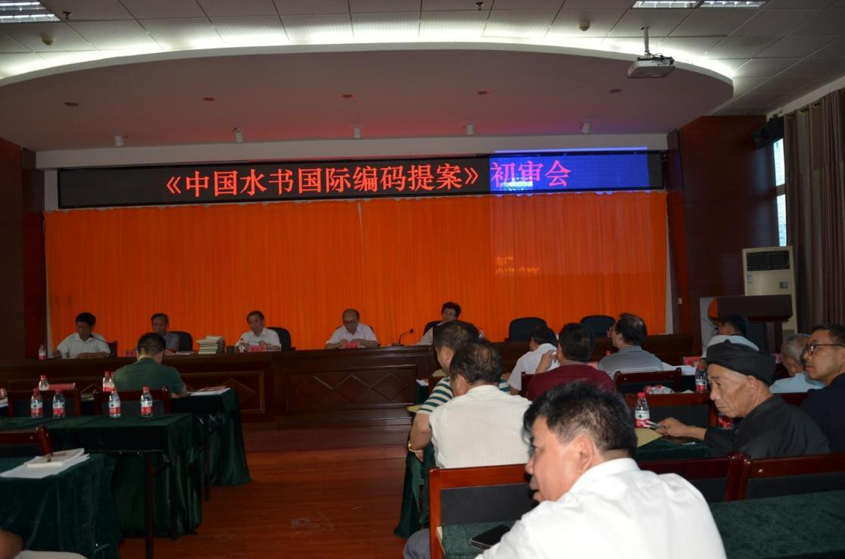

（**3**）**Publication Example**   
Bring Sui Culture into Campus《水族文化进校园读本》from Sandu Shui minority autonomous county

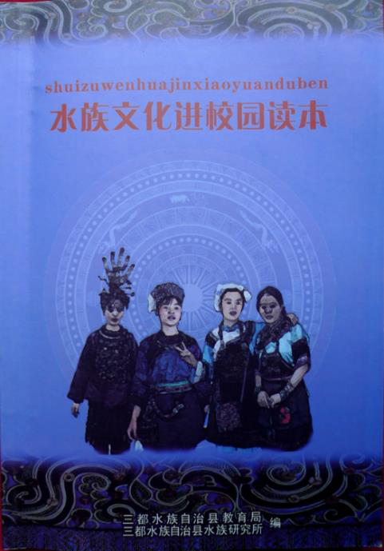

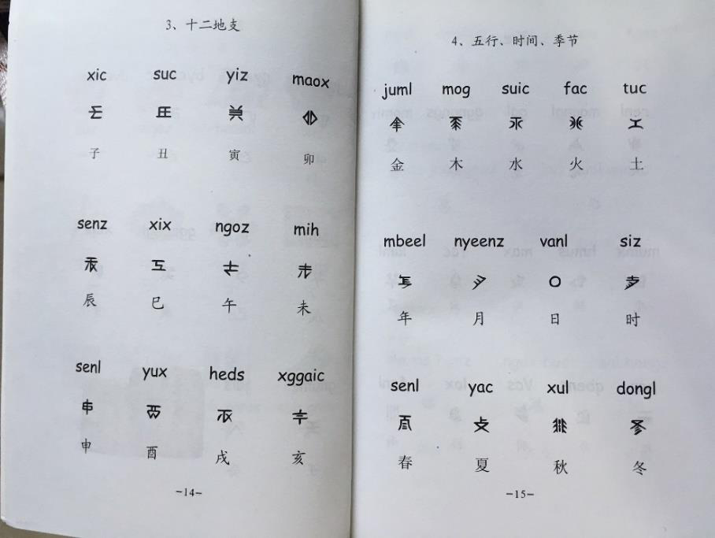

（**4**）**Meetings and contributors**

|  |
| --- |
| Aug 31, 2015 |

71

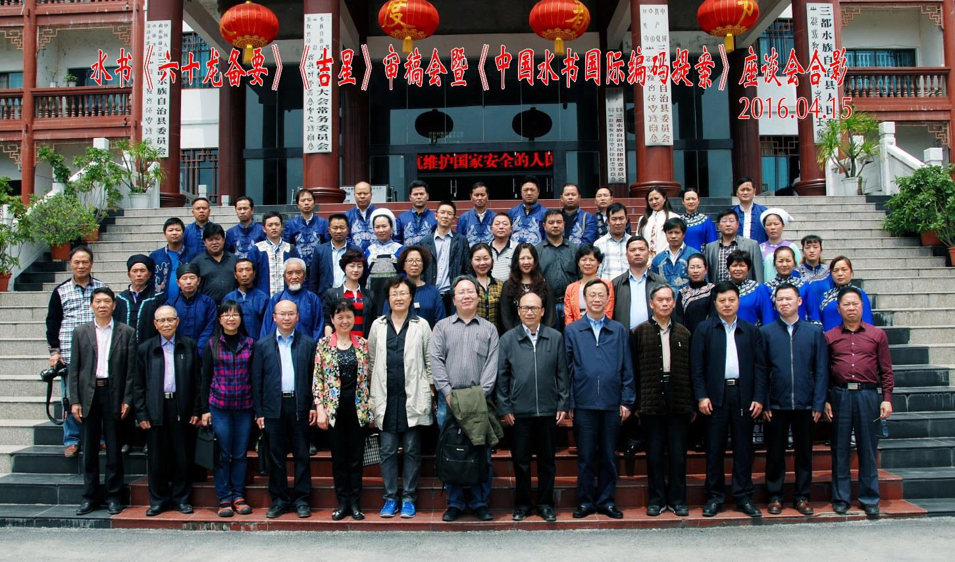

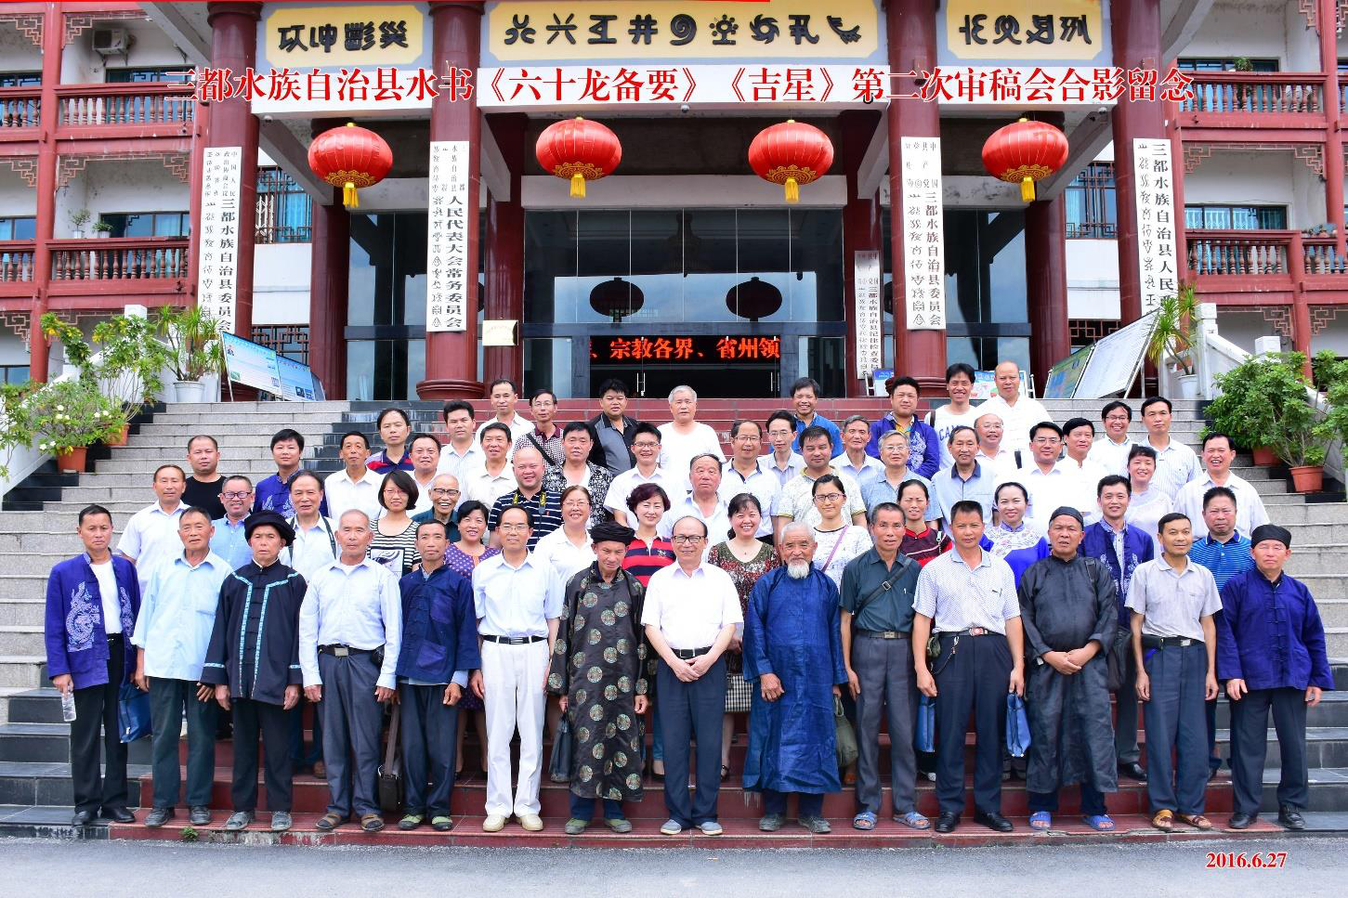

72

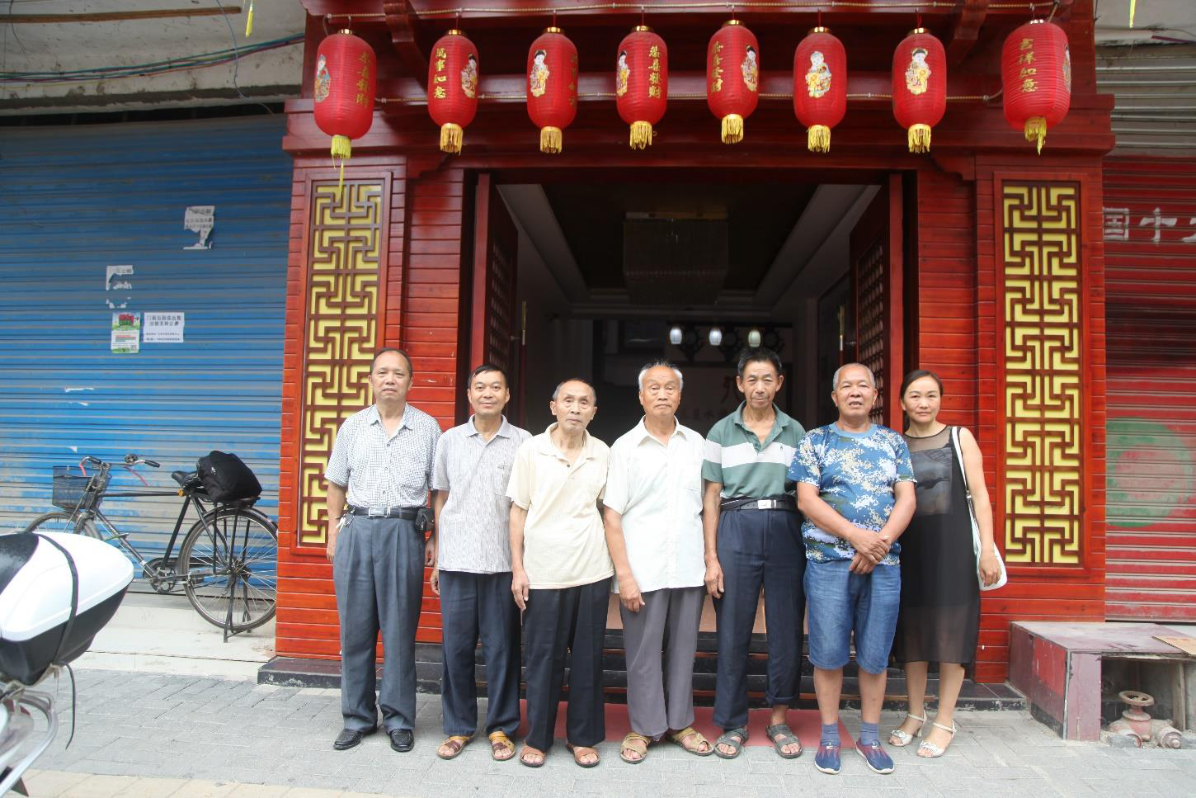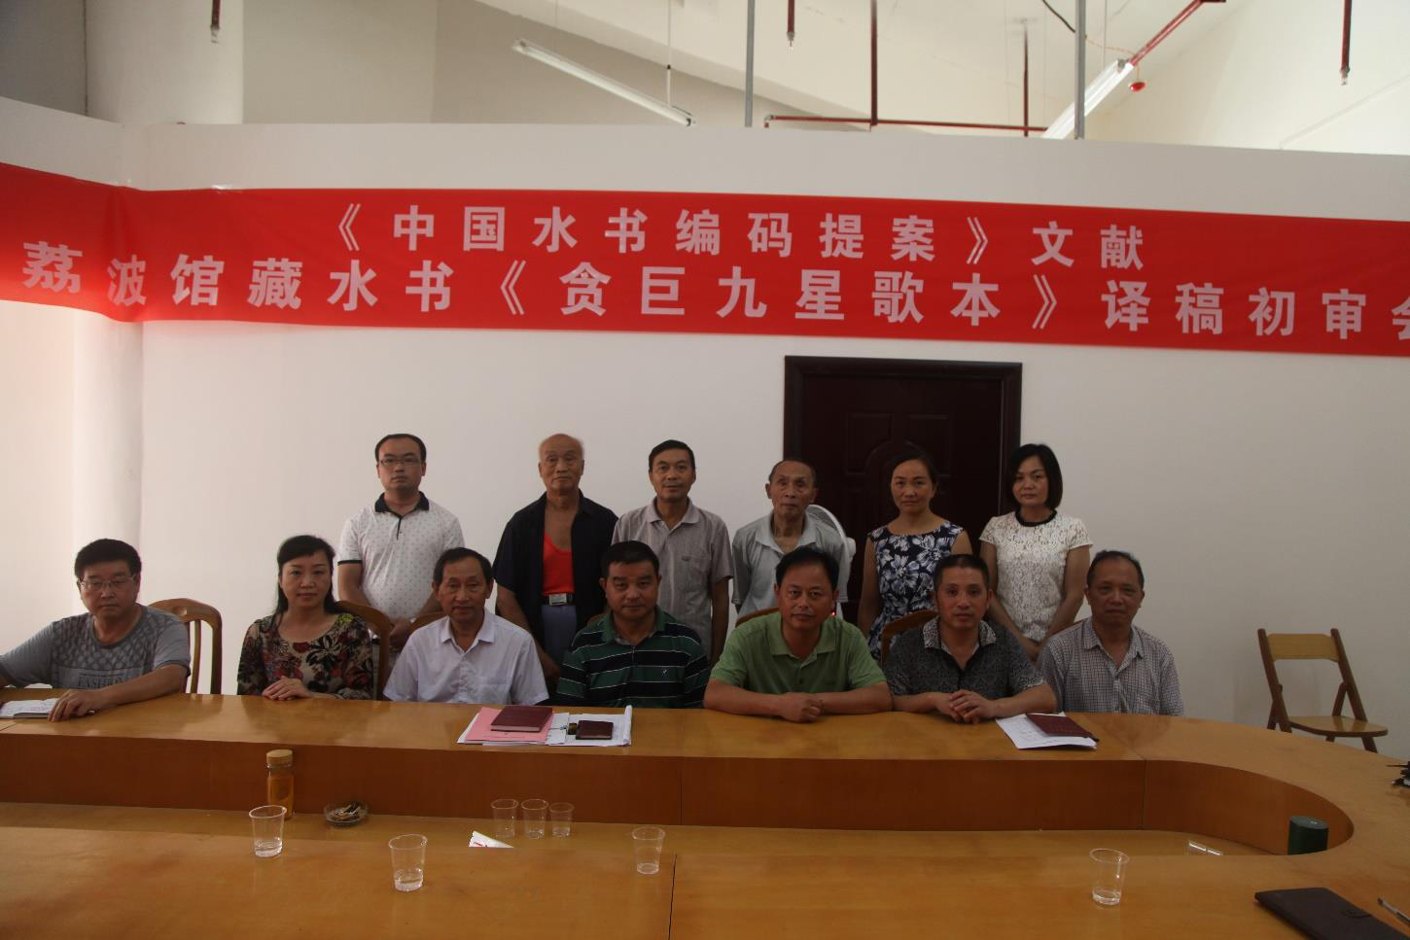

|  |
| --- |
| Shuishu working team from Libo Aug 2016 |

|  |
| --- |
| Shuishu masters from Libo Aug 2016 |

73

Nearly 36 Shuishu masters from Libo, Sandu, Dushan and Duyun counties in Guizhou Province participated in the

translation and assembly of Shuishu materials, some of whom have passed away.

10 from Sandu county: Yang Shengzhao 杨胜昭, Pan Xiuye 潘秀业, Wei Jian 韦见, Wei Jiaqiang 韦家强, Pan Biliang 潘必良, Pan Huanwen 潘焕文, Yang Xiulong 杨秀龙, Wei Shizhao 韦仕钊, Lu Changqian 陆常谦, Yang Shengji 杨盛基   
6 Shuishu masters from Libo county: Yao Qingjun 姚覃军, Meng Xineng 蒙熙能, Yao Yuanfang 姚元芳, Yao Shuntan 姚舜谈, Meng Wenbing 蒙文兵, Pan Laoping 潘老平   
4 Shuishu masters from Duyun: Meng JunChang 蒙君昌, WeiRongzu 韦荣祖, Meng Jiarong 蒙家荣, Wei Peijun 韦佩君

4 Shuishu masters from Dushan county：Wei Guangli 韦光礼, Wei Keru 韦克儒, WeiChunru 韦春儒, Wei Jinxian 韦锦贤.

4 Shuishu masters from Rongjiang county : Pan Guangdiao 潘光雕, Pan Guanglei 潘光磊, Pan Yuanchun 潘永香, Pan Shunlin 潘顺林   
4 Shuishu masters from Leishan county: Yang xiubiao 杨秀标, Lu Shaowu 陆绍武, Wang Zhiliag 王治良, Yang Xiuhe 杨秀和   
4 Shuishu masters from Danzhai：Pan Guangli 潘广礼, Pan Guangen 潘广恩, PanGuangtian 潘广田, Pan Guangjun 潘广均。

Many professionals (including the professors and students in Tsinghua University) and Sui researchers participated: Zhao Liming 赵丽明, Lai Chingju 赖静如, Liang Guanghua 梁光华, Pan Chaolin 潘朝霖, Wu Guibiao 吴贵飙, Luo Chunhan 罗春寒, Wei Xuechun 韦学纯, Shi Guoyi 石国义, Pan Maojing 潘茂金，Jiang Guosheng 蒋国生, Yao Binglie 姚炳烈, Pan Zhongxi 潘中西, Wei JinShi 韦锦诗, Wei Shifang 韦世方, Pan Zhengbo 潘政 波, Pan Xingwen 潘兴文, Pan Xiuming 潘秀明, Yang Yiqiu 杨毅秋, Wei Zhangbing 韦章柄, Meng Yaoyuan 蒙耀 远, Zhong Haizhen 钟海珍, Pan Mingqiao 潘明巧, Wei Shikai 韦仕凯, Shi Guomeng 石国勐、Wei Yong 韦永、Wu Yongmei 吴永梅, QinYijiao 覃毅姣, Meng Mingxia 蒙明霞, MoYingguang 莫映广, Meng YongTao 蒙咏桃, Meng Yongguo 蒙永国, WuZhenNa 吴珍娜, Wu Shanquan 吴善全,Luo Gang, Liu Chang, Zhang Junfeng, Ding Wuchen, Dong Yi, Shi Chenwei, Guan Chan, Xu Duoduo, Liu Jie, Song Chen, Jin Jiaping, Ma Jun, Bai Yunlong, Li Jia,

Den Qi, Li Shang, Wang Yijun, Xia Jinjing, Ding Biyuan, and David Kawatski and Adrian Cheuk.

And the government officials and leaders who organized the collection and arrangement: Hu Pingrong 胡品荣, Wu Yonghua 吴永华, Meng Xilin 蒙熙林, Pan Yonghui 潘永会, Wei Chengnian 韦成念, Pan Chongxian 潘宠宪, Wei Zhangbing, Meng Yongyi, Tang Xianliang, Pan Tianhua 潘天华, Pan Chaoxi 潘朝喜、PanZhongxi 潘中西、Wang Xingwu 王兴武、Pan Guangshu 潘广淑、Meng GuoYing 蒙国颖、Long Chengju 龙承举、Pan Guangxian 潘光宪、Wang Shiwen 王仕文、Lang Changxin 郎昌信、PanChun 潘春 etc.

74

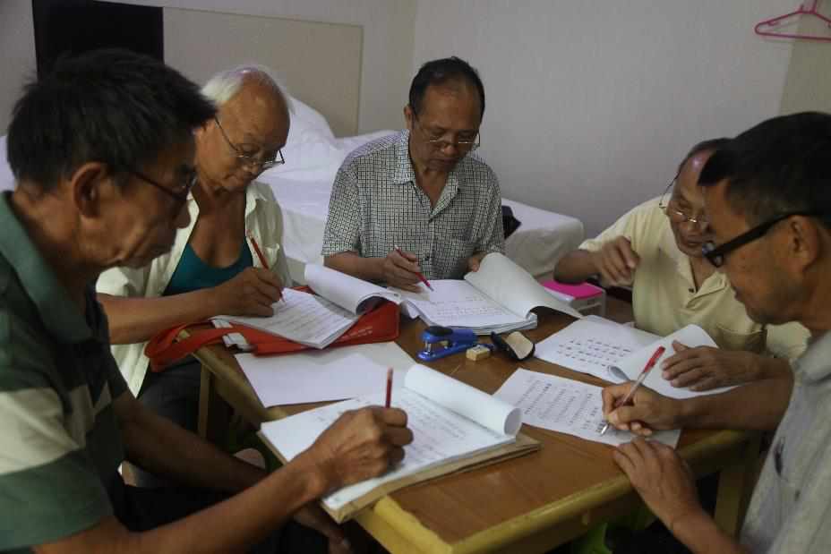

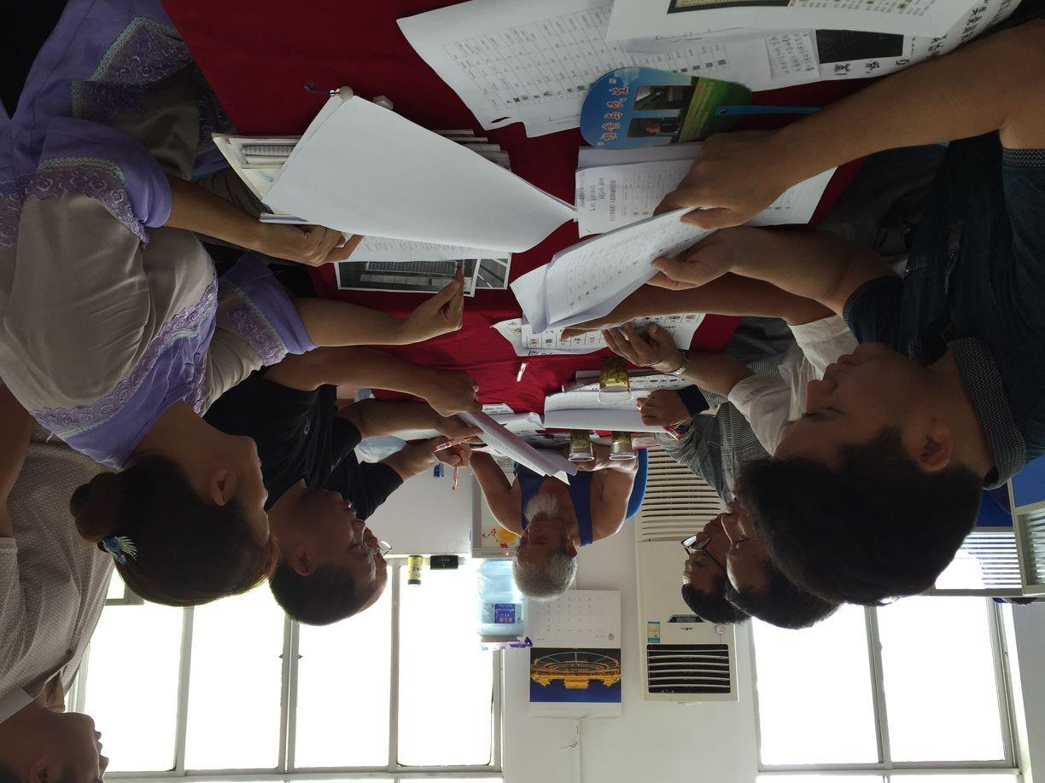

Since 2002 when we started collecting Shuishu for the first time until now, they have been devoted to the

translation and arrangement of Shuishu for ten years. Pay respect to them!

75

**6**． **References and related publications**

1. 水书《泐金•纪日卷》.贵州省档案局（馆）荔波县人民政府编. 中国首批《国家珍贵古籍名录》.贵州 人民出版社.2007.

2. 《清华大学馆藏水书文献 10 本》解读.清华大学图书馆.

3. 水书《陆道根原》解读.贵州省荔波县档案馆.

4. 水书《金银卷解读》.贵州省荔波县档案馆.中国首批《国家珍贵古籍名录》.

5. 水书《六十甲子时辰》解读.中国民族图书馆.

6. 水书《贪巨九星歌本》卷解读.贵州省荔波县档案馆.中国首批《国家珍贵古籍名录》.

7. 水书《六十龙备要》卷解读.贵州省三都县档案馆.中国首批《国家珍贵古籍名录》.

8. 水书《吉星》卷解读.贵州省三都县档案馆.中国首批《国家珍贵古籍名录》.

9. 水书《正七卷、壬辰卷》.贵州民族出版社.1994.

10. 曾晓渝,姚福祥.《汉水词典》.中国社会科学院民族研究所主编.四川民族出版社.1996.

11. 张振江.姚福祥.水书与水族社会》.中山大学出版社.2009.

12. Lai Ching-Ju 赖静如.李方桂《水话研究》之语言学研究.（博士论文）第 25 页第三章水语语音研究.2015.

Lai Ching-Ju (2015) A Linguistic Study of Li Fangkui's Sui Language Text Collection (PHD thesis CASS)

Lai Ching-Ju (2015) The process of Sui language Romanization- Some suggestion for the scheme for Sui phonetic alphabet draft in 1986 （水族语言书面化必经之路--对 1986 年《水语拼音方案》(草案)几点 建议贵州民族大学学报 2015 年）  
13. 梁光华.《水族水书语音语料库系统研究》.贵州民族出版社.2012.

14. 王传福,熊宗仁.《揭秘水书：水书先生访谈录》.贵州省档案馆贵州省史学会编.贵州民族出版社,2010. 15. 陈思.《水书揭秘》.光明日报出版社.2010.

16. 韦世方.《水书常用字典》.贵州省三都水族自治县水族研究所编.贵州民族出版社.2007.

17. 《中国水书》,四川出版集团,2007.

18. 水书【婚嫁卷】.贵州民族出版社.2009.

19. 水书【秘籍卷】.贵州民族出版社.2009.

20. 水书【正五卷】.贵州民族出版社.2010.

21. 水书【麒麟正七卷】（上下）.贵州民族出版社.2009.

22. 水书【金用卷】.贵州民族出版社.2010.

23. 水书【丧葬卷】.贵州民族出版社.2005.

24. 《中国水书探析》.中国文史出版社.2005.

25. 水书【丧葬卷】.贵州民族出版社.2005.

76